C++ language
Note:
- Most most important highlight : red
- Important highlight : yellow.
- Semi important highlight :green.
Note 2 :
- Important headline: blue
- Semi important headline:green

1.C and C++ are both programming languages that share similar syntax but have important differences
- Programming Paradigm: C is a procedural programming language, while C++ supports Object-Oriented Programming (OOP), allowing for concepts such as classes and objects.
- Exception Handling: C++ has built-in exception handling features that allow developers to manage errors more effectively. In C, errors must be handled manually.
- References: C does not have a concept of references; it only uses pointers. C++, on the other hand, supports references, which provide a more convenient way to refer to objects.
Overall, C++ enhances C by introducing OOP features and better error handling.
C was developed by Dennis Ritchie between the year 1969 and 1973 at AT&T Bell Labs. | C++ was developed by Bjarne Stroustrup in 1979.
C does no support polymorphism, encapsulation, and inheritance which means that C does not support object oriented programming. | C++ supports polymorphism, encapsulation, and inheritance because it is an object oriented programming language.
C is (mostly) a subset of C++. | C++ is (mostly) a superset of C.
Number of keywords in C:  * C90: 32  * C99: 37  * C11: 44  * C23: 59 | Number of keywords in C++:  * C++98: 63  * C++11: 73  * C++17: 73  * C++20: 81
For the development of code, C supports procedural programming. | C++ is known as hybrid language because C++ supports both procedural and object oriented programming paradigms.
Data and functions are separated in C because it is a procedural programming language. | Data and functions are encapsulated together in form of an object in C++.
C does not support information hiding. | Data is hidden by the Encapsulation to ensure that data structures and operators are used as intended.
Built-in data types is supported in C. | Built-in & user-defined data types is supported in C++.
C is a function driven language because C is a procedural programming language. | C++ is an object driven language because it is an object oriented programming.
Function and operator overloading is not supported in C. | Function and operator overloading is supported by C++.
C is a function-driven language. | C++ is an object-driven language
Functions in C are not defined inside structures. | Functions can be used inside a structure in C++.
Namespace features are not present inside the C. | Namespace is used by C++, which avoid name collisions.
Standard IO header is stdio.h. | Standard IO header is iostream.h.
Reference variables are not supported by C. | Reference variables are supported by C++.
Virtual and friend functions are not supported by C. | Virtual and friend functions are supported by C++.
C does not support inheritance. | C++ supports inheritance.
Instead of focusing on data, C focuses on method or process. | C++ focuses on data instead of focusing on method or procedure.
C provides malloc() and calloc() functions for dynamic memory allocation, and free() for memory de-allocation. | C++ provides new operator for memory allocation and delete operator for memory de-allocation.
Direct support for exception handling is not supported by C. | Exception handling is supported by C++.
scanf() and printf() functions are used for input/output in C. | cin and cout are used for input/output in C++.
C structures don’t have access modifiers. | C ++ structures have access modifiers.
There is no strict type checking in C programming language. | Strict type checking in done in C++. So many programs that run well in C compiler will result in many warnings and errors under C++ compiler.
C does not support overloading | C++ does support overloading
Type punning with unions is allows (C99 and later) | Type punning with unions is undefined behavior (except in very specific circumstances)
Named initializers may appear out of order | Named initializers must match the data layout of the struct
File extension is “.c” | File extension is “.cpp” or “.c++” or “.cc” or “.cxx”
Meta-programming: macros + _Generic() | Meta-programming: templates (macros are still supported but discouraged)
There are 32 keywords in the C | There are 97 keywords in the C++

Similarities between c/c++.
- Both the languages have a similar syntax.
- Code structure of both the languages are same.
- The compilation of both the languages is similar.
- They share the same basic syntax. Nearly all of C’s operators and keywords are also present in C++ and do the same thing.
- C++ has a slightly extended grammar than C, but the basic grammar is the same.
- Basic memory model of both is very close to the hardware.
- Same notions of stack, heap, file-scope and static variables are present in both the languages.

Why Learn C++?
- C++ is one of the most used and popular programming languages.
- C++ is used in making operating systems, embedded systems, and Graphical User Interfaces.
- It is an object-oriented programming language that implements all the OOPs concepts such as Abstraction, Encapsulation, and Inheritance, which gives a clear structure to programs and allows code to be reused, lowering development costs and providing security.
- It is portable and can be used to create applications that can be adapted to multiple platforms.
- C++ is easy to learn so that you can choose it as your first programming language.
- It makes programming easy for programmers to switch to C++ because its syntax is similar to C, Java, and C#.

2.C++ Basics

What is Syntax?
Syntax refers to the rules and regulations for writing statements in a programming language. They can also be viewed as the grammatical rules defining the structure of a programming language.

The C++ language also has its syntax for the functionalities it provides. Different statements have different syntax specifying their usage but C++ programs also have basic syntax rules that are followed throughout all the programs.

Basic Syntax of a C++ Program
We can learn about basic C++ Syntax using the following program.
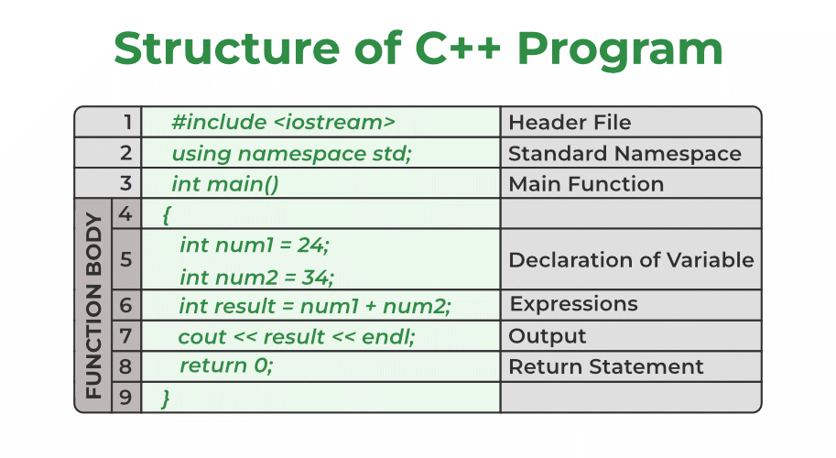
1. Header File
The header files contain the definition of the functions and macros we are using in our program. They are defined on the top of the C++ program.
In line #1, we used the #include <iostream> statement to tell the compiler to include an iostream header file library which stores the definition of the cin and cout standard input/output streams that we have used for input and output. #include is a preprocessor directive using which we import header files.
Syntax:
#include <library_name>
To know more about header files, please refer to the article – Header Files in C/C++.
2. Namespace
A namespace in C++ is used to provide a scope or a region where we define identifiers. It is used to avoid name conflicts between two identifiers as only unique names can be used as identifiers.
In line #2, we have used the using namespace std statement for specifying that we will be the standard namespace where all the standard library functions are defined.
Syntax:
using namespace std;
To know more about namespaces in C++, please refer to the article – Namespaces in C++.
3. Main Function
Functions are basic building blocks of a C++ program that contains the instructions for performing some specific task. Apart from the instructions present in its body, a function definition also contains information about its return type and parameters. To know more about C++ functions, please refer to the article Functions in C++.
In line #3, we defined the main function as int main(). The main function is the most important part of any C++ program. The program execution always starts from the main function. All the other functions are called from the main function. In C++, the main function is required to return some value indicating the execution status.
Syntax:
int main() {

... code ....
return 0;
}
4. Blocks
Blocks are the group of statements that are enclosed within { } braces. They define the scope of the identifiers and are generally used to enclose the body of functions and control statements.
The body of the main function is from line #4 to line #9 enclosed within { }.
Syntax:
{

// Body of the Function

return 0;
}
5. Semicolons
As you may have noticed by now, each statement in the above code is followed by a ( ; ) semicolon symbol. It is used to terminate each line of the statement of the program. When the compiler sees this semicolon, it terminates the operation of that line and moves to the next line.
Syntax:
any_statement ;
6. Identifiers
We use identifiers for the naming of variables, functions, and other user-defined data types. An identifier may consist of uppercase and lowercase alphabetical characters, underscore, and digits. The first letter must be an underscore or an alphabet.
Example:
int num1 = 24;
int num2 = 34;
num1 & num2 are the identifiers and int is the data type.
7. Keywords
In the C++ programming language, there are some reserved words that are used for some special meaning in the C++ program. It can’t be used for identifiers.
For example, the words int, return, and using are some keywords used in our program. These all have some predefined meaning in the C++ language.
There are total 95 keywords in C++. These are some keywords.

int void if while for auto bool break

this static new true false case char class
To know more about Identifiers and Keywords in C++, refer to the article C/C++ Tokens.
8. Basic Output cout
In line #7, we have used the cout stream object (declared in the <iostream> header file) to print the sum of two numbers to the standard output stream (stdout).
Syntax:
cout << result << endl;
To know more about basic input and output in C++, please refer to the article – Basic Input and Output in C.
Now, we have a better understanding of the basic syntax structure of the above C++ program. Let’s try to execute this program and see if it works correctly.
C++
Explain
// C++ program to demonstrate the basic syntax
// Header File Library
#include <iostream>

// Standard Namespace
using namespace std;

// Main Function
int main()
{

// Body of the Function

// Declaration of Variable
int num1 = 24;
int num2 = 34;

int result = num1 + num2;

// Output
cout << result << endl;

// Return Statement
return 0;
}
Output
58
The above program runs correctly and displays the specified output because we have followed the syntax rules of C++. We will learn more about these basic elements later

1. Class
A class is a template of an object. For example, the animal is a class & dog is the object of the animal class. It is a user-defined data type. A class has its own attributes (data members) and behavior (member functions). The first letter of the class name is always capitalized & use the class keyword for creating the class.
In line #3, we have declared a class named Calculate and its body expands from line #3 to line #7.
Syntax:
class class_name{
// class body
};
To know more about classes in C++, please refer to this article.
2. Data Members & Member Functions
The attributes or data in the class are defined by the data members & the functions that work on these data members are called the member functions.
Example:
class Calculate{

public:
int num1 = 50; // data member
int num2 = 30; // data member

// member function
int addition() {
int result = num1 + num2;
cout << result << endl;
}
};
In the above example, num1 and num2 are the data member & addition() is a member function that is working on these two data members. There is a keyword here public that is access modifiers. The access modifier decides who has access to these data members & member functions. public access modifier means these data members & member functions can get access by anyone.
3. Object
The object is an instance of a class. The class itself is just a template that is not allocated any memory. To use the data and methods defined in the class, we have to create an object of that class.
They are declared in the similar way we declare variables in C++.
Syntax:
class_name object_name;
We use dot operator ( . ) for accessing data and methods of an object.
To know more about objects in C++, please refer to the article – C++ Classes and Objects.
Now, let’s execute our code to see the output of the program.
C++
Explain
#include <iostream>
using namespace std;

class Calculate{

// Access Modifiers
public:
// data member
int num1 = 50;
int num2 = 30;

// member function
int addition() {
int result = num1 + num2;
cout << result << endl;
}
};

int main() {

// object declaration
Calculate add;
// member function calling
add.addition();

return 0;
}
Keywords: Keywords are specific reserved words in C each of which has a specific feature associated with it. Almost all of the words which help us use the functionality of the C language are included in the list of keywords. So you can imagine that the list of keywords is not going to be a small one! There are a total of 32 keywords in C:
break | try | catch | char | class | const | continue
default | delete | auto | else | friend | for | float
long | new | operator | private | protected | public | return
short | sizeof | static | this | typedef | enum | throw
mutable | struct | case | register | switch | and | or
namespace | static_cast | goto | not | xor | bool | do
double | int | unsigned | void | virtual | union | while
Identifiers: Identifiers are used as the general terminology for naming of variables, functions and arrays. These are user defined names consisting of arbitrarily long sequence of letters and digits with either a letter or the underscore(_) as a first character. Identifier names must differ in spelling and case from any keywords. You cannot use keywords as identifiers; they are reserved for special use. Once declared, you can use the identifier in later program statements to refer to the associated value. A special kind of identifier, called a statement label, can be used in goto statements.

Here are some examples of valid and invalid identifiers in C++:
Valid Identifiers | Invalid Identifiers
_name | #name (Cannot start with special character except ‘_’)
Number89 | 2num (Cannot start with a digit)
first_name | first name (Cannot include space)
_last_name_ | string (Cannot be same as a keyword)
Difference between Keyword and Identifier:
SR. NO. | KEYWORD | IDENTIFIER
1 | Keywords are predefined word that gets reserved for working program that have special meaning and cannot get used anywhere else. | Identifiers are the values used to define different programming items such as variables, integers, structures, unions and others and mostly have an alphabetic character.
2 | Specify the type/kind of entity. | Identify the name of a particular entity.
3 | It always starts with a lowercase letter. | First character can be a uppercase, lowercase letter or underscore.
4 | A keyword should be in lower case. | An identifier can be in upper case or lower case.
5 | A keyword contains only alphabetical characters. | An identifier can consist of alphabetical characters, digits and underscores.
6 | They help to identify a specific property that exists within a computer language. | They help to locate the name of the entity that gets defined along with a keyword.
7 | No special symbol, punctuation is used. | No punctuation or special symbol except ‘underscore’ is used.
8 | Examples of keywords are: int, char, if, while, do, class etc. | Examples of identifiers are: Test, count1, high_speed, etc.
Tokens:
In C++, tokens can be defined as the smallest building block of C++ programs that the compiler understands. Every word in a C++ source code can be considered a token.
Types of Tokens in C++
We have several types of tokens each of which serves a specific purpose in the syntax and semantics of C++. Below are the main types of tokens in C++:
- Identifiers
- Keywords
- Constants
- Strings
- Special Symbols
- Operators
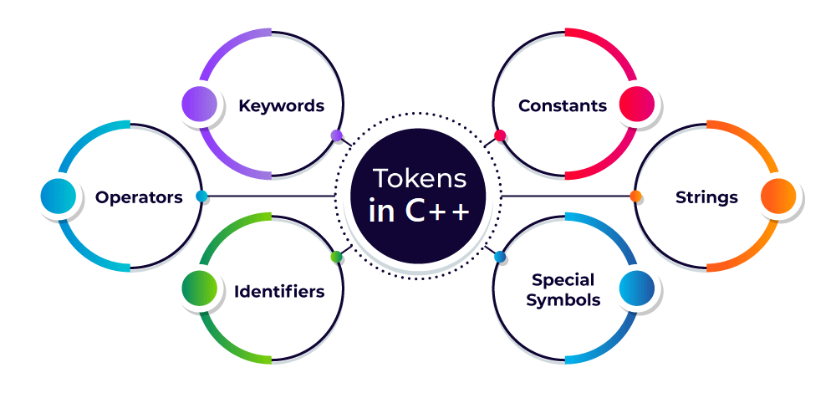

5. Special Symbols
Special symbols are the token characters having specific meanings within the syntax of the programming language. These symbols are used in a variety of functions, including ending the statements, defining control statements, separating items, and more.
Below are the most common special symbols used in C++ programming:
- Semicolon (;): It is used to terminate the statement.
- Square brackets []: They are used to store array elements.
- Curly Braces {}: They are used to define blocks of code.
- Scope resolution (::): Scope resolution operator is used to access members of namespaces, classes, etc.
- Dot (.): Dot operator also called member access operator used to access class and struct members.
- Assignment operator ‘=’: This operator is used to assign values to variables.
- Double-quote (“): It is used to enclose string literals.
- Single-quote (‘): It is used to enclose character literals.

Types of Comments in C++
In C++ there are two types of comments :
- Single-line comment
- Multi-line comment
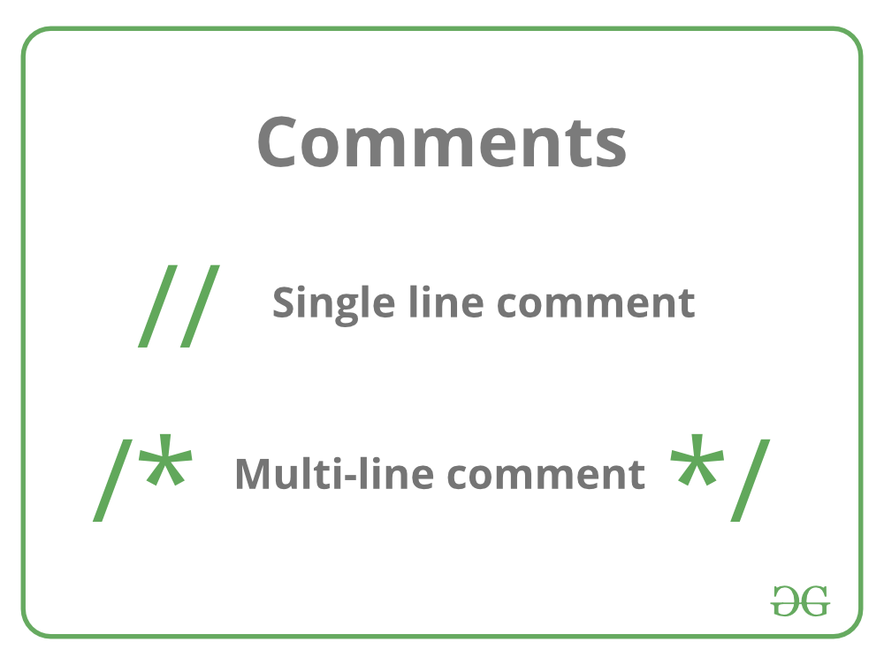

3.C++ Variables and Constants
Variables in C++ is a name given to a memory location. It is the basic unit of storage in a program.
- The value stored in a variable can be changed during program execution.
- A variable is only a name given to a memory location, all the operations done on the variable effects that memory location.
- In C++, all the variables must be declared before use.

How to Declare Variables?
A typical variable declaration is of the form:
// Declaring a single variable
type variable_name;
// Declaring multiple variables:
type variable1_name, variable2_name, variable3_name;

A variable name can consist of alphabets (both upper and lower case), numbers, and the underscore ‘_’ character. However, the name must not start with a number. The C++ Course covers the types of variables in C++ and how to use them effectively in your programs.
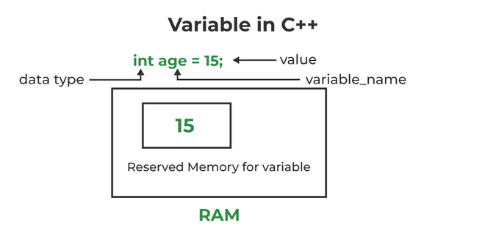
Initialization of a variable in C++
stored in the variable.
Examples:
// Declaring float variable
float simpleInterest;
// Declaring integer variable
int time, speed;
// Declaring character variable
char var;
We can also provide values while declaring the variables as given below:
int a=50,b=100; //declaring 2 variable of integer type
float f=50.8; //declaring 1 variable of float type
char c='Z'; //declaring 1 variable of char type

Rules For Declaring Variable
- The name of the variable contains letters, digits, and underscores.
- The name of the variable is case sensitive (ex Arr and arr both are different variables).
- The name of the variable does not contain any whitespace and special characters (ex #,$,%,*, etc).
- All the variable names must begin with a letter of the alphabet or an underscore(_).
- We cannot used C++ keyword(ex float,double,class)as a variable name.

- Valid variable names:
- int x; //can be letters
int _yz; //can be underscores
int z40;//can be letters
- Invalid variable names:
- int 89; Should not be a number
int a b; //Should not contain any whitespace
int double;// C++ keyword CAN NOT BE USED

Difference Between Variable Declaration and Definition

The variable declaration refers to the part where a variable is first declared or introduced before its first use. A variable definition is a part where the variable is assigned a memory location and a value. Most of the time, variable declaration and definition are done together.
See the following C++ program for better clarification:
// C++ program to show difference between
// definition and declaration of a
// variable
#include <iostream>
using namespace std;

int main()
{
// this is declaration of variable a
int a;

// this is initialisation of a
a = 10;

// this is definition = declaration + initialisation
int b = 20;

// declaration and definition
// of variable 'a123'
char a123 = 'a';

// This is also both declaration and definition
// as 'c' is allocated memory and
// assigned some garbage value.
float c;

// multiple declarations and definitions
int _c, _d45, e;

// Let us print a variable
cout << a123 << endl;

return 0;
}
Output
a
Time Complexity: O(1)
Space Complexity: O(1)

1.Types of Variables in C++
There are three types of variables based on the scope of variables in C++
- Local Variables
- Instance Variables
- Static Variables
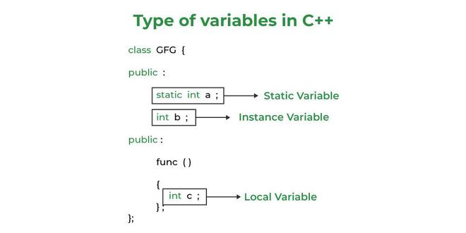
Let us now learn about each one of these variables in detail.
- Local Variables: A variable defined within a block or method or constructor is called a local variable.
  - These variables are created when entered into the block or the function is called and destroyed after exiting from the block or when the call returns from the function.
  - The scope of these variables exists only within the block in which the variable is declared. i.e. we can access this variable only within that block.
  - Initialization of local variables is not mandatory, but it is highly recommended to ensure they have a defined value before use.
- Instance Variables: Instance variables are non-static variables and are declared in a class outside any method, constructor, or block.
  - As instance variables are declared in a class, these variables are created when an object of the class is created and destroyed when the object is destroyed.
  - Unlike local variables, we may use access specifiers for instance variables. If we do not specify any access specifier then the default access specifier will be used.
  - Initialization of Instance Variable is not Mandatory.
  - Instance Variable can be accessed only by creating objects.
- Static Variables: Static variables are also known as Class variables.
  - These variables are declared similarly as instance variables, the difference is that static variables are declared using the static keyword within a class outside any method constructor or block.
  - Unlike instance variables, we can only have one copy of a static variable per class irrespective of how many objects we create.
  - Static variables are created at the start of program execution and destroyed automatically when execution ends.
  - Initialization of Static Variable is not Mandatory. Its default value is 0
  - If we access the static variable like the Instance variable (through an object), the compiler will show the warning message and it won’t halt the program. The compiler will replace the object name with the class name automatically.
  - If we access the static variable without the class name, the Compiler will automatically append the class name.
Instance Variable Vs Static Variable
- Differences between Instance Variables and Static Variables
Copies and Allocation:
- Instance Variable: Each object of a class has its own copy of the instance variable. This means that each object can maintain its own state independently.
- Static Variable: There is only one copy of a static variable per class, regardless of how many objects are created from that class. All objects share this single instance of the static variable.
Modification Impact:
- Instance Variable: Changes made to an instance variable using one object do not affect the instance variable of other objects. Each object operates with its own independent copy.
- Static Variable: Changes to a static variable are reflected across all objects of the class since static variables are shared. If one object modifies the static variable, all objects will observe this updated value.
Accessing Variables:
- Instance Variables: Instance variables are accessed through object references. For example, if you have an instance obj of class Example, you can access the instance variable b using obj.b.
- Static Variables: Static variables can be accessed directly using the class name, without needing to create an instance of the class. For example, Example.a can be used to access the static variable a.
- Example Code
- Here’s your provided code example that illustrates the difference:
C++ Example Code
cpp
#include <iostream>
using namespace std;

class Example {
public:
static int a; // Static variable
int b; // Instance variable

Example() {
// Constructor
}
};

// Definition of the static variable
int Example::a = 0;

int main() {
Example obj1; // Create first object
Example obj2; // Create second object

// Accessing and modifying instance variable
obj1.b = 5; // Set instance variable in obj1
obj2.b = 10; // Set instance variable in obj2

cout << "Object 1's instance variable b: " << obj1.b << endl; // Output: 5
cout << "Object 2's instance variable b: " << obj2.b << endl; // Output: 10

// Accessing and modifying static variable
Example::a = 20; // Set static variable
cout << "Static variable a through Example: " << Example::a << endl; // Output: 20

// Changing the static variable through obj1
obj1.a = 30; // This changes Example::a as it is static
cout << "Static variable a after change: " << Example::a << endl; // Output: 30
cout << "Static variable a through obj2: " << obj2.a << endl; // Output: 30

return 0;
}

Explanation of the Code
Class Definition:

The class Example contains a static variable a (common to all instances) and an instance variable b (each instance has its own copy).
Static Variable Definition:

The static variable a is defined outside the class with int Example::a = 0;, which initializes it.
Object Creation:

Two objects obj1 and obj2 are created from the Example class.
Accessing Instance Variables:

The instance variable b is modified independently for each object. The outputs will show that obj1.b and obj2.b can store different values.
Accessing Static Variables:

The static variable a is set and accessed using the class name (Example::a).
Modifying the static variable through obj1 affects all instances, including obj2.
Output of the Program
Running the program will produce the following output:

less
Object 1's instance variable b: 5
Object 2's instance variable b: 10
Static variable a through Example: 20
Static variable a after change: 30
Static variable a through obj2: 30
This output illustrates the behavior of instance variables and static variables in C++.
The syntax for static and instance variables:
class Example
{
static int a; // static variable
int b; // instance variable
}

Important facts to learn in variables.

1.Scope of Variables in C++
In general, the scope is defined as the extent up to which something can be worked with. In programming also the scope of a variable is defined as the extent of the program code within which the variable can be accessed or declared or worked with. There are mainly two types of variable scopes:
- Local Variables
- Global Variables
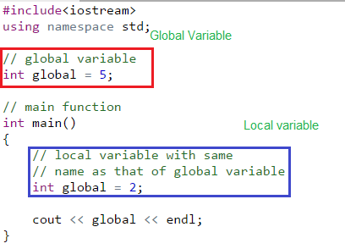
Now let’s understand each of the scope at a greater detail:
Local Variables
Variables defined within a function or block are said to be local to those functions.
- Anything between ‘{‘ and ‘}’ is said to inside a block.
- Local variables do not exist outside the block in which they are declared, i.e. they can not be accessed or used outside that block.
- Declaring local variables: Local variables are declared inside a block.
- C++
// CPP program to illustrate
// usage of local variables
#include<iostream>
using namespace std;

void func()
{
/* this variable is local to the
function func() and cannot be
accessed outside this function */
int age=18;
}

int main()
{
cout<<"Age is: "<<age;

return 0;
}
Output:
Error: age was not declared in this scope
The above program displays an error saying “age was not declared in this scope”. The variable age was declared within the function func() so it is local to that function and not visible to portion of program outside this function.
Rectified Program : To correct the above error we have to display the value of variable age from the function func() only. This is shown in the below program:
- C++
// CPP program to illustrate
// usage of local variables
#include<iostream>
using namespace std;

void func()
{
// this variable is local to the
// function func() and cannot be
// accessed outside this function
int age=18;
cout<<age;
}

int main()
{
cout<<"Age is: ";
func(); //displayed the func()

return 0;
}
Output:
Age is: 18
Global Variables
As the name suggests, Global Variables can be accessed from any part of the program.
- They are available through out the life time of a program.
- They are declared at the top of the program outside all of the functions or blocks.
- Declaring global variables: Global variables are usually declared outside of all of the functions and blocks, at the top of the program. They can be accessed from any portion of the program.
- C++
// CPP program to illustrate
// usage of global variables
#include<iostream>
using namespace std;

// global variable
int global = 5;

// global variable accessed from
// within a function
void display()
{
cout<<global<<endl;
}

// main function
int main()
{
display();

// changing value of global
// variable from main function
global = 10;
display();
}
Output:
5
10
In the program, the variable “global” is declared at the top of the program outside all of the functions so it is a global variable and can be accessed or updated from anywhere in the program.
What if there exists a local variable with the same name as that of global variable inside a function?
Let us repeat the question once again. The question is : if there is a variable inside a function with the same name as that of a global variable and if the function tries to access the variable with that name, then which variable will be given precedence("অগ্রাধিকার)? Local variable or Global variable? Look at the below program to understand the question:
- C++
// CPP program to illustrate
// scope of local variables
// and global variables together
#include<iostream>
using namespace std;

// global variable
int global = 5;

// main function
int main()
{
// local variable with same
// name as that of global variable

int global = 2;
cout << global << endl;
}
Look at the above program. The variable “global” declared at the top is global and stores the value 5 where as that declared within main function is local and stores a value 2. So, the question is when the value stored in the variable named “global” is printed from the main function then what will be the output? 2 or 5?
- Usually when two variable with same name are defined then the compiler produces a compile time error. But if the variables are defined in different scopes then the compiler allows it.
- Whenever there is a local variable defined with same name as that of a global variable then the compiler will give precedence to the local variable
How to access a global variable when there is a local variable with same name?
What if we want to do the opposite of above task. What if we want to access global variable when there is a local variable with same name? To solve this problem we will need to use the scope resolution operator. Below program explains how to do this with the help of scope resolution operator.
- C++
// C++ program to show that we can access a global
// variable using scope resolution operator :: when
// there is a local variable with same name
#include<iostream>
using namespace std;

// Global x
int x = 0;

int main()
{
// Local x
int x = 10;
cout << "Value of global x is " << ::x;
cout<< "\nValue of local x is " << x;
return 0;
}
Output:
Value of global x is 0
Value of local x is 10

2.Can Global Variables be dangerous ?
In a small code, we can track values of global variables. But if the code size grows, they make code less understandable (hence less maintainable). It becomes difficult to track which function modified the value and how.

// A C++ program to demonstrate that a
// global variables make long code less
// maintainable.

int c = 1;

int fun1()
{
// 100 lines of code that
// may modify c and also
// call fun2()
}

void fun2()
{
// 100 lines of code that
// may modify c and also
// call fun1()
}

void main()
{
// 1000 lines of code

c = 0;

// 1000 lines of code

// At this point, it becomes difficult
// to trace value of c
if (c == 1)
cout << "c is 1" << endl
else
cout << "c is not 1 << endl
}

- In above code, we notice one of the biggest problem of global variable that is Debugging. It means if we trying to figure out where that variable c has changed between thousands of lines of code is very difficult job.
- In a multithreaded environment, a global variable may change more than once (in different execution orders) and cause more problems.
- Global variables are generally used for constants. Using them for non-const values is not recommended.

3.C++ 17 | New ways to Assign values to Variables

C++ 17 introduced many new ways to declare a variable. Earlier assignment and declaration was done using “=”
Example:
int a = 5;
But now 2 more ways are introduced in C++17. They are:
- Constructor initialization: In this way, the value of the variable is enclosed in parentheses ( () ). In this way, value can be passed in two ways shown below.
#include <iostream>
using namespace std;

// Driver Code
int main()
{

// Declaring the variable in parentheses
// Method 1
int a(5);
cout << "a = " << a;

// Declaring the variable in parentheses
// Method 2
int b = (10);
cout << endl
<< "b = " << b;

return 0;
}
Output:
a = 5
b = 10
Explanation
In C++ 17, the variable can be declared by providing values through parenthesis too. The difference between constructor initialization and the old normal way of initialization is that it will always return last value in the parenthesis no matter what it’s magnitude or sign is.

For example,

a=(2, 21, -50, 1)
The value stored in a would be 1.
- Uniform initialization: In this way, the value of the variable is enclosed in curly braces ( {} ) instead of parentheses. In this way, the value can be passed in two ways shown below.
#include <iostream>
using namespace std;

int main()
{

// Declaring the variable in curly braces
// Method 1
int a{ 3 };
cout << "a = " << a;

// Declaring the variable in curly braces
// Method 2
int b = { 7 };
cout << endl
<< "b = " << b;

return 0;
}
Output:
a = 3
b = 7
Unlike Constructor initialization, this assigning method can only take one value in the braces. Providing multiple values would return a compile error.

For example,

int b={7, 12};
Output
prog.cpp: In function 'int main()':
prog.cpp:9:12: error: scalar object 'b' requires one element in initializer
int b={7, 12};

4.How to return local variables from a function in C++
In C++, returning a local variable from a function may result in an error due to the deallocation of variable memory after some value is returned from the function. But there are some ways using which we can safely return the local variables or the address of local variables and manipulate the data from the caller function.
In this article, we will discuss the various methods to return local variables from a function in C++.
What are Local Variables?
Local variables are those variables that are declared inside a block or function. Their scope is limited to that block and their lifetime is till the end of the block i.e. they are created when program control comes to the block and deleted when the program control goes out of the block
What happens when you try to return a local variable as usual?
All the local variables of a function are stored inside the stack. This stack is removed when some value is returned by the function and all the function data is deleted. So, if we try to access the local variable after some value is returned by the function, the segmentation fault occurs.
Example
In the following code, when the array is created inside a function and returned to the caller function, it throws a runtime error as the array was created in the stack memory, and therefore it is deleted once the function ends.
- C++
// C++ program to illustrate the segementation fault caused
// due to accessing local varaible after function ends
#include <bits/stdc++.h>
using namespace std;

// Function to return an
// array
int* fun()
{
int arr[5] = { 1, 2, 3, 4, 5 };
return arr;
}
// Driver Code
int main()
{

int* arr = fun();
// Will cause error
cout << arr[2];

return 0;
}
Output
4195974
Output
Segmentation Fault (SIGSEGV)
This C++ program will likely result in a segmentation fault because it attempts to access a local variable that has gone out of scope. Specifically, the array arr is defined inside the fun function as a local variable. When fun returns, the memory allocated for arr is no longer valid, but the program attempts to use the pointer to this invalid memory.

Explanation:
- Inside fun, the array arr is created on the stack.
- fun returns a pointer to the array arr.
- Once fun ends, the memory for arr is deallocated because it is a local variable.
- main tries to access arr[2] using the returned pointer, but this is undefined behavior since arr's memory has already been freed.
- Corrected Version:

To fix this issue, you can allocate the array dynamically using new or std::vector:
Using Dynamic Memory Allocation (new):

cpp
Copy code
#include <bits/stdc++.h>
using namespace std;

// Function to return a dynamically allocated array
int* fun() {
int* arr = new int[5]{1, 2, 3, 4, 5};
return arr;
}

// Driver Code
int main() {
int* arr = fun();
// Safe to access
cout << arr[2];
// Free dynamically allocated memory
delete[] arr;

return 0;
}
Using std::vector:

cpp
Copy code
#include <bits/stdc++.h>
using namespace std;

// Function to return a vector
vector<int> fun() {
return {1, 2, 3, 4, 5};
}

// Driver Code
int main() {
vector<int> arr = fun();
// Safe to access
cout << arr[2];

return 0;
}
In the first version, we use new to allocate memory dynamically, which remains valid until delete[] is called. In the second version, std::vector is used, which manages memory automatically and is safer to use in C++.
How to return a local variable from a function?
There are two ways to access the local variables or array of a function after the function execution.
1. Static Variables or Static Arrays
The lifetime of the static variables is different from the lifetime of the local variables. Static variables live throughout the program Hence, if we make the local variables static, we can access it even after the function ends.
Example
- C++
// Program to demonstrate how to return
// static variables from a function
#include <iostream>
using namespace std;

int& getStaticVariable()
{
// Static variable
static int staticVar = 10;

// Returning Static variable
return staticVar;
}

int main()
{
int& result = getStaticVariable();
cout << "Value of static variable: " << result << endl;

// Modifying the static variable
result += 10;
cout << "Updated value of static variable: " << result
<< endl;

return 0;
}
Output
Value of static variable: 10
Updated value of static variable: 20
2. Dynamic Variables and Arrays
Dynamic Variables and arrays are allocated memory on the heap. Unlike statically created variables, the lifespan of memory allocated on the heap exists until it is deallocated explicitly using the free() function or delete operator. Hence, if we create the local variables dynamically, we return the variables from a function.
Example
- C++
// Program to demonstrate how to return
// dynamic arrays from a function
#include <iostream>
using namespace std;

int* createDynamicArray(int size)
{
// Dynamically allocate an array
int* dynamicArray = new int[size];
for (int i = 0; i < size; ++i) {
// Set values in the array
dynamicArray[i] = i * 2;
}
// Return the dynamically allocated
// array
return dynamicArray;
}

int main()
{
// Create and get the dynamically allocated
// array
int* returnedArray = createDynamicArray(5);

// Use the returned array
for (int i = 0; i < 5; ++i) {
cout << "Element " << i << ": " << returnedArray[i]
<< endl;
}

// Deallocate the dynamic array
delete[] returnedArray;

return 0;
}
Output
Element 0: 0
Element 1: 2
Element 2: 4
Element 3: 6
Element 4: 8
Conclusion
By creating the static variables or creating variables dynamically, we can access the local variables of a function even after the function returns some value. This is because the lifetime of static variables begins when the function is called in which it is declared and ends when the execution of the program completes. The dynamic variables are assigned memory on hep which is deallocated only when the memory is explicitly deallocated using the delete operator

5.C++ Global Variables

In C++ programming languages, a variable is a name provided to memory to store different data types. Variable values can change anytime while running the program and each variable has its own scope (or region) where it is valid to access the variable using the name given to him.
In programming, variables are not all equal. Their scope, lifespan, and accessibility in the program depend on where and how they are declared. There are two types of variables based on their scope.
- Local variable – The scope of these variables exists only within the block in which the variable is declared. i.e. we can access this variable only within that block.
- Global variable – Global variables are a special type with the widest scope possible. It is declared outside of all of the functions and blocks, at the top of the program. They can be accessed from any portion of the program.
Global Variable in C++
Global variables are the variables that are declared outside of any function or class and can be accessed by any part of the program. They are generally declared at the beginning of the source file after the header file. They are available throughout the lifetime of a program and accessible from anywhere within the program.
Declaration of a Global Variable in C++
To create a global variable, we simply declare it at the top of the source file, after the header files, and before the main function. In C++, all the variables must be declared before use.
Example 1
- C++
// C++ Program to illustrate Global Variable
// header files
#include <iostream>
using namespace std;

// global variable
int x = 10; // x is a global variable initialized to 10

// main function
int main()
{
cout << x;
return 0;
}
Output
10
Explanation
- In this example, `x` is a global variable that can store an integer value.
- It is initialized to 10 when the program starts.
- Since it is declared outside any function or class, it can be accessed and modified by any function or class in the program.
Now, someone might wonder why you would want to use global variables in your program.
Example 2
- C++
// C++ program to illustrate
// usage of global variables
#include <iostream>
using namespace std;

// global variable
int global = 5;

// global variable accessed from
// within a function
void display() { cout << global << endl; }

// main function
int main()
{
display();

// changing value of global
// variable from main function
global = 10;
display();
}
Output
5
10
Explanation
- In this example ‘int global’ is a Global Variable that stores an integer value.
- It initialized with 5 when the program started.
- After that call goes to the main function and then it calls the display function which prints the global variable.
- After printing 5, the value of the global variable is changed to 10. Now again the display function is called and the new value of the variable global 10 is printed.
Benefits of Using Global Variables
Following are some main benefits that global variables provide:
- Global Variable can be accessed directly by all the functions without passing an argument in the program.
- Global Variables are very useful when many functions access the same variable.
- Global Variable required only a one-time declaration in the program.
Drawbacks of Using Global Variables
Global variables also come with some drawbacks. Some of them are:
- Sometimes Global Variable can cause conflict issues as multiple programs try to modify them at the same time, generally in multithreading programs.
- It can sometimes lead to variable shadowing.
- Global Variables can make code less readable and less maintainable.
- Also, there is some security and bugs concern as they can be modified or accessed by any part of the program.
- Sometimes if you use a larger number in the global variable there is a high chance of error in the program.
Conclusion
Global variables are very useful but ‘difficult to track’ variables in C++ programming language. They are useful because we can access the same variable in any part of the program but it must be used such that it doesn’t make code less readable and less maintainable, and also takes care of security aspects. Therefore, it is suggested to use global variables rarely and carefully and prefer local variables or other alternatives whenever possible.

6.Condition Variables in C++ Multithreading

In C++, the condition variable is a synchronization primitive that is used to notify the other threads in a multithreading environment that the shared resource is free to access. It is defined as the std::condition_variable class inside the <condition_variable> header file.
Prerequisite: C++ Multithreading, Mutex in C++.
Need for Condition Variable in C++
Condition variable is especially needed in cases where one thread has to wait for another thread execution to continue the work. For example, the producer-consumer relationship, sender-receiver relationship, etc.
In these cases, the condition variable makes the thread wait till it is notified by the other thread. It is used with mutex locks to block access to the shared resource when one thread is working on it.
Syntax of std::condition_variable
The syntax to declare a condition variable is simple:
std::condition_variable variable_name;
After that, we use the associated method for different operations.
Condition Variable Methods
The std::condition_variable methods contain some member methods to provide the basic functionalities. Some of these are:
S. No. | Function | Description
1 | wait() | This function tells the current thread to wait till the condition variable is notified.
2 | wait_for() | This function tells the current thread to wait for some specific time duration. If the condition variable is notified earlier than the time duration, the thread awakes. The time is specified as relative time.
3 | wait_until() | This function is similar to the wait_for() but here, the time duration is defined as the absolute time.
4 | notify_one() | This function notifies one of the waiting threads that the shared resource is free to access. The thread selection is random.
5 | notify_all() | This function notifies all of the threads.
Example: Program to Illustrate the Use of Condition Variable
C++
Explain
// C++ Program to illustrate the use of Condition Variables
#include <condition_variable>
#include <iostream>
#include <mutex>
#include <thread>

using namespace std;

// mutex to block threads
mutex mtx;
condition_variable cv;

// function to avoid spurios wakeup
bool data_ready = false;

// producer function working as sender
void producer()
{
// Simulate data production
this_thread::sleep_for(chrono::seconds(2));

// lock release
lock_guard<mutex> lock(mtx);

// variable to avoid spurious wakeup
data_ready = true;

// logging notification to console
cout << "Data Produced!" << endl;

// notify consumer when done
cv.notify_one();
}

// consumer that will consume what producer has produced
// working as reciever
void consumer()
{
// locking
unique_lock<mutex> lock(mtx);

// waiting
cv.wait(lock, [] { return data_ready; });

cout << "Data consumed!" << endl;
}

// drive code
int main()
{
thread consumer_thread(consumer);
thread producer_thread(producer);

consumer_thread.join();
producer_thread.join();

return 0;
}
Output
Data Produced!
Data consumed!
In this program, the consumer thread uses the condition variable cv to wait until data_ready is set to true while the producer thread sleeps for two seconds to mimic data generation.
Errors Associated with C++ Condition Variable
The condition variable is prone to the following errors:
- Spurious Wakeup: Spurious wakeup refers to the condition when the consumer/receiver thread finishes its work before it is notified by the producer/sender. In the above example, we have used the variable data_ready precisely to cope with this error.
- Lost Wakeup: Lost wakeup refers to the condition when the sender sends the notification but there is no receiver in the wait for the notification yet.
Advantages of Condition Variable
The following are the major advantages of using condition variables in our C++ program:
- The condition variable provide a way to signal the thread of a particular condition.
- The sleeping thread in condition variable is different from the waiting threads consuming less resources.
Conclusion
In conclusion, condition variables are an effective tool for assuring safe access to shared data, lowering contention, and establishing effective thread synchronisation in multi-threaded C++ programmes. They are commonly used with the mutex to provide an efficient synchronization technique.

7.Templates and Static variables in C++
Function templates and static variables:
Each instantiation of function template has its own copy of local static variables. For example, in the following program there are two instances: void fun(int ) and void fun(double ). So two copies of static variable i exist.

#include <iostream>

using namespace std;

template <typename T>
void fun(const T& x)
{
static int i = 10;
cout << ++i;
return;
}

int main()
{
fun<int>(1); // prints 11
cout << endl;
fun<int>(2); // prints 12
cout << endl;
fun<double>(1.1); // prints 11
cout << endl;
getchar();
return 0;
}
Output of the above program is:

11
12
11
Class templates and static variables:
The rule for class templates is same as function templates
Each instantiation of class template has its own copy of member static variables. For example, in the following program there are two instances Test and Test. So two copies of static variable count exist.

#include <iostream>

using namespace std;

template <class T> class Test
{
private:
T val;
public:
static int count;
Test()
{
count++;
}
// some other stuff in class
};

template<class T>
int Test<T>::count = 0;

int main()
{
Test<int> a; // value of count for Test<int> is 1 now
Test<int> b; // value of count for Test<int> is 2 now
Test<double> c; // value of count for Test<double> is 1 now
cout << Test<int>::count << endl; // prints 2
cout << Test<double>::count << endl; //prints 1

getchar();
return 0;
}

2.Constants in C++
In C++, constants are values that remain fixed throughout the execution of a program. In this article, we will discuss various ways to define and use constants in C++.
Constants in C++
Constants in C++ refer to variables with fixed values that cannot be changed. Once they are defined in the program, they remain constant throughout the execution of the program. They are generally stored as read-only tokens in the code segment of the memory of the program. They can be of any available data type in C++ such as int, char, string, etc.
How to Define Constants in C++?
We can define the constants in C++ using three ways:
Using const Keyword
Using constexpr Keyword
Using #define Preprocessor
Let’s discuss these methods in detail.
1. Constant using const Keyword
Defining constants using const keyword is one of the older methods that C++ inherited from C language. In this method, we add the const keyword in the variable definition as shown below:
Syntax for const Keyword
const DATATYPE variable_name = value;
We first use the const keyword to make sure that our variable is a constant followed by the datatype of the constant variable then proceed with the name of the constant variable and finally give the appropriate value to the constant variable.
Note: We have to initialize the constant variable at the time of declaration as we cannot modify the value of it later in the program.
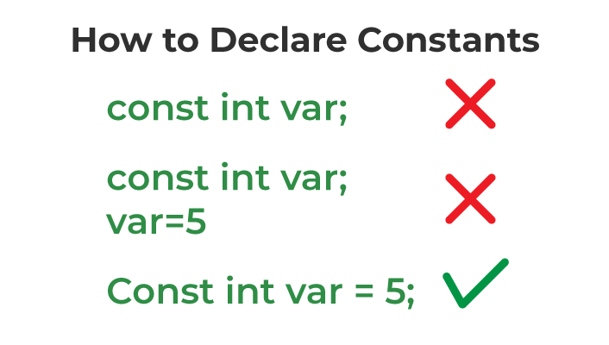

Example for const Keyword
C++
// C++ program to define how to use the const keyword
#include <iostream>
using namespace std;

int main()
{
// declaring a variable
int var = 10;

// declaring a constant variable
const int cons = 24;

cout << "Initial Value:" << endl;
cout << "var: " << var << endl;
cout << "cons: " << cons << endl;

// changing the value of both the constants
var = 24;
cons = 0;

cout << "Final Value:" << endl;
cout << "var: " << var << endl;
cout << "cons: " << cons << endl;

return 0;
}
Output
./Solution.cpp: In function 'int main()':
./Solution.cpp:19:10: error: assignment of read-only variable 'cons'
cons = 0;
2. Constants using constexpr Keyword
The constexpr keyword is similar to const keyword and is also used to declare constants in C++. But the major difference is that the constexpr constants are initialized at compiler time, which is why their value must be known at the compile time. On the other hand, const keyword constants can be initialized at runtime and compile time.
Syntax for constexpr
constexpr DATATYPE variable_name = value ;
We first use the constexpr keyword to make sure that our variable is a constant followed by the DataType of the constant variable then proceed with the name of the constant variable and finally give the appropriate value to the constant variable.
Example for constexpr Keyword
C++
// C++ program to illustrate the use of constexpr keyword
#include <iostream>
using namespace std;

int main()
{
// defining constant
int constexpr hoursIn_day = 24;

// printing value
cout << "Total hours in a day: " << hoursIn_day;
}
Output
Total hours in a day: 24
The above snippet uses the const and constexpr keywords to define constant the number of hours in a day (hoursIn_day)
3. Constants using #define Preprocessor
We can also define constants using the #define. Constants created using the #define preprocessor are called “macro constants”. Unlike the other methods, constants defined using this method simply work as an alias for their value which is substituted during preprocessing.
It is the less preferable way to define a constant in C++ due to the lack of type safety.
Syntax
#define MACRO_NAME replacement_value
We use the #define directive to create a macro. First, we start with the #define directive, followed by the name we want to give to our macro. Then, we provide a replacement value for the macro. Whenever the preprocessor encounters this macro in our code, it will replace it with the specified value.
Example
C++
// C++ Program to illustrate the use of #define to create a
// constant
#include <iostream>
using namespace std;

// using #define to create a macro
#define Side 5

int main()
{
// using constant
const double area = Side * Side;

cout << "The area of square with side 5 is ";
cout << area;

return 0;
}
Output
The area of square with side 5 is 25
Explanation:
We have defined the macro constant Side with the value of 5. We then used it to find the area of the square. The macro constant Side is global meaning it is not restricted to a single function. Also, note that we cannot get user input for the macro constant.
Important Points about Constants
The following are some major properties of C++ constants discussed in the article:
Constants are the variables with fixed values.
We have to initialize the constants at the time of declaration and we cannot change this value later in the program.
const and constexpr can be used to define a constant.
#define is also used to define a macro constant.

Important to learn for constants.

1.Data type of character constants in C and C++

In C, data type of character constants is int, but in C++, data type of same is char. If we save below program as test.c then we get 4 as output (assuming size of integer is 4 bytes) and if we save the same program as test.cpp then we get 1(assuming size of char is 1 byte)
- C++
- C
// C++ program demonstrating that data type of character
// constants in C++ is same as 'char'

#include <iostream>
using namespace std;

int main() {

cout << sizeof('a');

return 0;
}

// This code is contributed by sarajadhav12052009
Output of C++ program:
1
Output of C program:
4

2.How to Define Constants in C++?
In C++, constants are the tokens that are used to represent those values that cannot be changed during the program execution. It is defined only once and remains the same throughout the execution of the program. C++ provides various different methods to define constants. In this article, we will discuss such methods to define constants and see how they are different form each other.
Different Ways to Define Constants in C++
In general, we can define constants using the const keyword but C++ also provides more methods to define constants. Some of the methods to define constants in C++ are:
- Using const Keyword
- Using Macro
- Using enum
- Using constexpr
Constants defined using each of these keywords have some similar and different properties. Let's discuss them one by one.
1. Constants Using const Keyword
This method is one of the most prominent and most basic methods of defining constants. Here, we use the keyword const as a prefix in the variable declaration.
Syntax
const variable_type variable_name = value;
We have to assign the value to the constant variable at the declaration as we cannot change its value after declaration.
Example
C++
Explain
// C++ program to demonstrate the declaration of constant
// using const keyword
#include <iostream>
using namespace std;

int main()
{
const float PI = 3.14;

cout << PI << endl;

// trying to change the value
PI = 111; // error will occur here

cout << PI << endl;

return 0;
}
Output
main.cpp: In function ‘int main()’:
main.cpp:13:8: error: assignment of read-only variable ‘PI’
13 | PI = 111; // error will occur here
| ~~~^~~~~
2. Defining Constant Using #define
Defining constants as a macro (using #define) is different from the method using const keyword as the constants are just a placeholder for the actual value. This alias is replaced by its value during the preprocessing.
Syntax
#define constantName value
Here, ConstantName is the name which is used as an alias to its value.
Example
The below example demonstrates the declaration of constant using #define.
C++
Explain
// C++ program to define constant using #define
#include <iostream>
using namespace std;

// defining constant
#define half 0.5

int main()
{
int base = 10;
int height = 10;
// Storing the value of area in a float data type
float area = half * base * height;
// calculating area of triangle
cout << "The area of right angle triangle is: " << area;

return 0;
}
Output
The area of right angle triangle is: 50
3. Defining Constant Using enum
Enumeration (or enum) is a data type in which we assign some name to the integer values. We can use this property to create constant values. Enumerations are generally used where multiple constants are required and we can only use the integer values.
Syntax
enum enum_Name
{
constant1 = value;
constant2 = value;
}
Example
The below demonstrates the use of enum to create multi constants.
C++
Explain
// C++ program to demonstrate the use of enum to create
// multi constants
#include <iostream>
using namespace std;

// defining multiple constants using enum
enum No_Color { RED = 4, GREEN = 6, BLUE = 10 };

int main()
{

// printing values of all balls
cout << "The no. of Red Balls is " << RED << endl;
cout << "The no. of Green Balls is " << GREEN << endl;
cout << "The no. of Blue Balls is " << BLUE << endl;
return 0;
}
Output
The no. of Red Balls is 4
The no. of Green Balls is 6
The no. of Blue Balls is 10
4. Defining Constant Using constexpr
In the C++11 and later versions, we can also use 'constexpr' keyword to declare constants. It its the modern and safe way to declare the constants in C++.This 'constexpr' keyword ensures that the value is processed at compile time instead of runtime to improve the execution efficiency.
Syntax
constexpr DataType constantName = value;
Example
The below example demonstrates the use of constexpr to define constant.
C++
Explain
// C++ program to demonstrate the use of constexpr to define
// constant.
#include <iostream>
using namespace std;

// Using constexpr to declare a constant variable
constexpr int Num = 5;

// Using constexpr to define a constant function
constexpr int factorial(int n)
{
return (n <= 1) ? 1 : n * factorial(n - 1);
}

int main()
{
// Using the constexpr constant variable
constexpr int res = factorial(Num);
cout << "Factorial of " << Num << " is: " << res
<< endl;

return 0;
}
Output
Factorial of 5 is: 120
Conclusion
In conclusion, constants in C++ programming are used to represent values that remain unchanged during program execution. The const keyword and other methods like #define, enum, and constexpr, allows us to declare and define constants as required. We can choose any of the above method based on our convenience and

3.Storage Classes in C++ with Examples
C++ Storage Classes are used to describe the characteristics of a variable/function. It determines the lifetime, visibility, default value, and storage location which helps us to trace the existence of a particular variable during the runtime of a program. Storage class specifiers are used to specify the storage class for a variable.
Syntax
To specify the storage class for a variable, the following syntax is to be followed:
storage_class var_data_type var_name;
C++ uses 6 storage classes, which are as follows:
- auto Storage Class
- register Storage Class
- extern Storage Class
- static Storage Class
- mutable Storage Class
- thread_local Storage Class
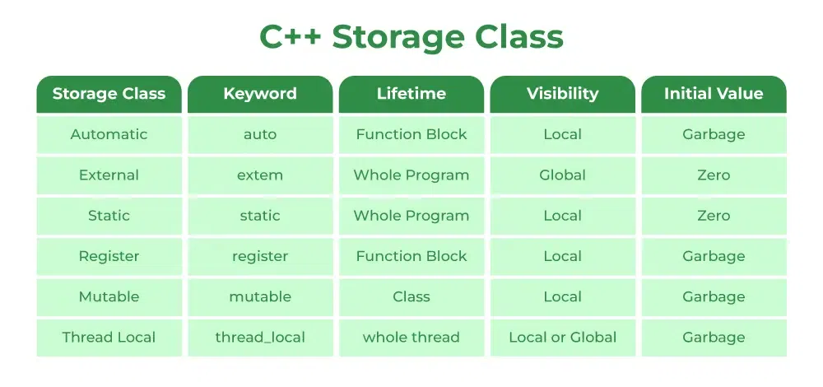
Below is a detailed explanation of each storage class:
1. auto Storage Class
The auto storage class is the default class of all the variables declared inside a block. The auto stands for automatic and all the local variables that are declared in a block automatically belong to this class.
Properties of auto Storage Class Objects
- Scope: Local
- Default Value: Garbage Value
- Memory Location: RAM
- Lifetime: Till the end of its scope
Example of auto Storage Class
C++
Explain
// C++ Program to illustrate the auto storage class
// variables
#include <iostream>
using namespace std;

void autoStorageClass()
{

cout << "Demonstrating auto class\n";

// Declaring an auto variable
int a = 32;
float b = 3.2;
char* c = "GeeksforGeeks";
char d = 'G';

// printing the auto variables
cout << a << " \n";
cout << b << " \n";
cout << c << " \n";
cout << d << " \n";
}

int main()
{

// To demonstrate auto Storage Class
autoStorageClass();

return 0;
}
Output
Demonstrating auto class
32
3.2
Note: Earlier in C++, we could use the auto keyword to declare the auto variables explicitly but after C++11, the meaning of auto keyword is changed and we could no longer use it to define the auto variables.
2. extern Storage Class
The extern storage class simply tells us that the variable is defined elsewhere and not within the same block where it is used (i.e. external linkage). Basically, the value is assigned to it in a different block and this can be overwritten/changed in a different block as well. An extern variable is nothing but a global variable initialized with a legal value where it is declared in order to be used elsewhere.
A normal global variable can be made extern as well by placing the ‘extern’ keyword before its declaration/definition in any function/block. The main purpose of using extern variables is that they can be accessed between two different files which are part of a large program.
Properties of extern Storage Class Objects
- Scope: Global
- Default Value: Zero
- Memory Location: RAM
- Lifetime: Till the end of the program.
Example of extern Storage Class
C++
Explain
// C++ Program to illustrate the extern storage class
#include <iostream>
using namespace std;

// declaring the variable which is to
// be made extern an initial value can
// also be initialized to x
int x;
void externStorageClass()
{

cout << "Demonstrating extern class\n";

// telling the compiler that the variable
// x is an extern variable and has been
// defined elsewhere (above the main
// function)
extern int x;

// printing the extern variables 'x'
cout << "Value of the variable 'x'"
<< "declared, as extern: " << x << "\n";

// value of extern variable x modified
x = 2;

// printing the modified values of
// extern variables 'x'
cout << "Modified value of the variable 'x'"
<< " declared as extern: \n"
<< x;
}

int main()
{

// To demonstrate extern Storage Class
externStorageClass();

return 0;
}
Output
Demonstrating extern class
Value of the variable 'x'declared, as extern: 0
Modified value of the variable 'x' declared as extern:
2
For more information on how extern variables work, have a look at this link.
3. static Storage Class
The static storage class is used to declare static variables which are popularly used while writing programs in C++ language. Static variables have the property of preserving their value even after they are out of their scope! Hence, static variables preserve the value of their last use in their scope.
We can say that they are initialized only once and exist until the termination of the program. Thus, no new memory is allocated because they are not re-declared. Global static variables can be accessed anywhere in the program.
Properties of static Storage Class
- Scope: Local
- Default Value: Zero
- Memory Location: RAM
- Lifetime: Till the end of the program
Note: Global Static variables can be accessed in any function.
Example of static Storage Class
C++
Explain
// C++ program to illustrate the static storage class
// objects
#include <iostream>
using namespace std;

// Function containing static variables
// memory is retained during execution
int staticFun()
{
cout << "For static variables: ";
static int count = 0;
count++;
return count;
}

// Function containing non-static variables
// memory is destroyed
int nonStaticFun()
{
cout << "For Non-Static variables: ";

int count = 0;
count++;
return count;
}

int main()
{

// Calling the static parts
cout << staticFun() << "\n";
cout << staticFun() << "\n";

// Calling the non-static parts

cout << nonStaticFun() << "\n";

cout << nonStaticFun() << "\n";

return 0;
}
Output
For static variables: 1
For static variables: 2
For Non-Static variables: 1
For Non-Static variables: 1
4. register Storage Class
The register storage class declares register variables using the ‘register’ keyword which has the same functionality as that of the auto variables. The only difference is that the compiler tries to store these variables in the register of the microprocessor if a free register is available. This makes the use of register variables to be much faster than that of the variables stored in the memory during the runtime of the program. If a free register is not available, these are then stored in the memory only.
An important and interesting point to be noted here is that we cannot obtain the address of a register variable using pointers.
Properties of register Storage Class Objects
- Scope: Local
- Default Value: Garbage Value
- Memory Location: Register in CPU or RAM
- Lifetime: Till the end of its scope
Example of register Storage Class
C++
Explain
// C++ Program to illustrate the use of register variables
#include <iostream>
using namespace std;

void registerStorageClass()
{

cout << "Demonstrating register class\n";

// declaring a register variable
register char b = 'G';

// printing the register variable 'b'
cout << "Value of the variable 'b'"
<< " declared as register: " << b;
}
int main()
{

// To demonstrate register Storage Class
registerStorageClass();
return 0;
}
Output
Demonstrating register class
Value of the variable 'b' declared as register: G
Note: The register keyword is deprecated in C++17 onwards.
5. mutable Storage Class
Sometimes there is a requirement to modify one or more data members of class/struct through the const function even though you don’t want the function to update other members of class/struct. This task can be easily performed by using the mutable keyword. The keyword mutable is mainly used to allow a particular data member of a const object to be modified.
When we declare a function as const, this pointer passed to the function becomes const. Adding a mutable to a variable allows a const pointer to change members.
Properties of mutable Storage Class
The mutable specifier does not affect the linkage or lifetime of the object. It will be the same as the normal object declared in that place.
Example of mutable Storage Class
C++
Explain
// C++ program to illustrate the use of mutalbe storage
// class specifiers
#include <iostream>
using std::cout;

class Test {
public:
int x;

// defining mutable variable y
// now this can be modified
mutable int y;

Test()
{
x = 4;
y = 10;
}
};

int main()
{
// t1 is set to constant
const Test t1;

// trying to change the value
t1.y = 20;
cout << t1.y;

// Uncommenting below lines
// will throw error
// t1.x = 8;
// cout << t1.x;
return 0;
}
Output
20
6. thread_local Storage Class
The thread_local Storage Class is the new storage class that was added in C++11. We can use the thread_local storage class specifier to define the object as thread_local. The thread_local variable can be combined with other storage specifiers like static or extern and the properties of the thread_local object changes accordingly.
Properties of thread_local Storage Class
- Memory Location: RAM
- Lifetime: Till the end of its thread
Example of thread_local Storage Class
C++
Explain
// C++ program to use thread_local storage specifier
#include <iostream>
#include <mutex>
#include <thread>

using namespace std;

// Defining thread-local variable
thread_local int value = 10;
// Mutex for synchronization
mutex mtx;

int main()
{
// Created 3 threads
// Modify value in thread 1
thread th1([]() {
value += 18;
lock_guard<mutex> lock(mtx);
cout << "Thread 1 value: " << value << '\n';
});

thread th2([]() {
// Modify value in thread 2
value += 7;
lock_guard<mutex> lock(mtx);
cout << "Thread 2 value: " << value << '\n';
});

thread th3([]() {
// Modify value in thread 3
value += 13;
lock_guard<mutex> lock(mtx);
cout << "Thread 3 value: " << value << '\n';
});

// Wait for all threads to finish
th1.join();
th2.join();
th3.join();

// Print the value of value in the main thread
cout << "Main thread value: " << value << '\n';

return 0;
}
Output
Thread 1 value Value: 28
Thread 2 value Value: 17
Thread 3 value Value: 23
Main thread value Value: 10
As we can see, each thread got its own copy of the thread_local variable and was only assigned the value that was specified in its callable.

4.Static Keyword in C++
Prerequisite: Static variables in C
The static keyword has different meanings when used with different types. We can use static keywords with:
- Static Variables: Variables in a function, Variables in a class
- Static Members of Class: Class objects and Functions in a class. Let us now look at each one of these uses of static in detail.
Static Variables
Static variables in a Function: When a variable is declared as static, space for it gets allocated for the lifetime of the program. Even if the function is called multiple times, space for the static variable is allocated only once and the value of the variable in the previous call gets carried through the next function call. This is useful for implementing coroutines in C/C++ or any other application where the previous state of function needs to be stored.
C++
Explain
// C++ program to demonstrate
// the use of static Static
// variables in a Function
#include <iostream>
#include <string>
using namespace std;

void demo()
{
// static variable
static int count = 0;
cout << count << " ";

// value is updated and
// will be carried to next
// function calls
count++;
}

int main()
{
for (int i = 0; i < 5; i++)
demo();
return 0;
}
Output
0 1 2 3 4
You can see in the above program that the variable count is declared static. So, its value is carried through the function calls. The variable count is not getting initialized every time the function is called. As a side note, Java doesn’t allow static local variables in functions.
For a thorough understanding of static variables and memory management in C++, check out our Complete C++ Course, where you’ll learn how to use static in classes, functions, and more.
Static variables in a class: As the variables declared as static are initialized only once as they are allocated space in separate static storage so, the static variables in a class are shared by the objects. There can not be multiple copies of the same static variables for different objects. Also because of this reason static variables can not be initialized using constructors.
C++
Explain
// C++ program to demonstrate static
// variables inside a class

#include <iostream>
using namespace std;

class GfG {
public:
static int i;

GfG(){
// Do nothing
};
};

int main()
{
GfG obj1;
GfG obj2;
obj1.i = 2;
obj2.i = 3;

// prints value of i
cout << obj1.i << " " << obj2.i;
}
Output
undefined reference to `GfG::i'
collect2: error: ld returned 1 exit status
You can see in the above program that we have tried to create multiple copies of the static variable i for multiple objects. But this didn’t happen. So, a static variable inside a class should be initialized explicitly by the user using the class name and scope resolution operator outside the class as shown below:
C++
Explain
// C++ program to demonstrate static
// variables inside a class

#include <iostream>
using namespace std;

class GfG {
public:
static int i;

GfG(){
// Do nothing
};
};

int GfG::i = 1;

int main()
{
GfG obj;
// prints value of i
cout << obj.i;
}
Output
1
Static Members of Class
Class objects as static: Just like variables, objects also when declared as static have a scope till the lifetime of the program. Consider the below program where the object is non-static.
C++
Explain
// CPP program to illustrate
// when not using static keyword
#include <iostream>
using namespace std;

class GfG {
int i;

public:
GfG()
{
i = 0;
cout << "Inside Constructor\n";
}
~GfG() { cout << "Inside Destructor\n"; }
};

int main()
{
int x = 0;
if (x == 0) {
GfG obj;
}
cout << "End of main\n";
}
Output
Inside Constructor
Inside Destructor
End of main
In the above program, the object is declared inside the if block as non-static. So, the scope of a variable is inside the if block only. So when the object is created the constructor is invoked and soon as the control of if block gets over the destructor is invoked as the scope of the object is inside the if block only where it is declared. Let us now see the change in output if we declare the object as static.
C++
Explain
// CPP program to illustrate
// class objects as static
#include <iostream>
using namespace std;

class GfG {
int i = 0;

public:
GfG()
{
i = 0;
cout << "Inside Constructor\n";
}

~GfG() { cout << "Inside Destructor\n"; }
};

int main()
{
int x = 0;
if (x == 0) {
static GfG obj;
}
cout << "End of main\n";
}
Output
Inside Constructor
End of main
Inside Destructor
You can clearly see the change in output. Now the destructor is invoked after the end of the main. This happened because the scope of static objects is throughout the lifetime of the program.
Static functions in a class: Just like the static data members or static variables inside the class, static member functions also do not depend on the object of the class. We are allowed to invoke a static member function using the object and the ‘.’ operator but it is recommended to invoke the static members using the class name and the scope resolution operator. Static member functions are allowed to access only the static data members or other static member functions, they can not access the non-static data members or member functions of the class.
C++
Explain
// C++ program to demonstrate static
// member function in a class
#include <iostream>
using namespace std;

class GfG {
public:
// static member function
static void printMsg() { cout << "Welcome to GfG!"; }
};

// main function
int main()
{
// invoking a static member function
GfG::printMsg();
}
Output
Welcome to GfG!
Related Articles:
- Quiz on Static Keyword
- Static data members in C++
- When are static objects destroyed?
- Interesting facts about static member functions
- Can static functions be virtual?
- Comparison of static keyword in C++ and Java
- Static functions in C

4.C++ Data Types and Literals
All variables use data type during declaration to restrict the type of data to be stored. Therefore, we can say that data types are used to tell the variables the type of data they can store. Whenever a variable is defined in C++, the compiler allocates some memory for that variable based on the data type with which it is declared. Every data type requires a different amount of memory.
C++ supports a wide variety of data types and the programmer can select the data type appropriate to the needs of the application. Data types specify the size and types of values to be stored. However, storage representation and machine instructions to manipulate each data type differ from machine to machine, although C++ instructions are identical on all machines.
C++ supports the following data types:
- Primary or Built-in or Fundamental data type
- Derived data types
- User-defined data types
To explore data types and their applications in detail, our Complete C++ Course covers primitive and advanced data types with practical coding exercises.
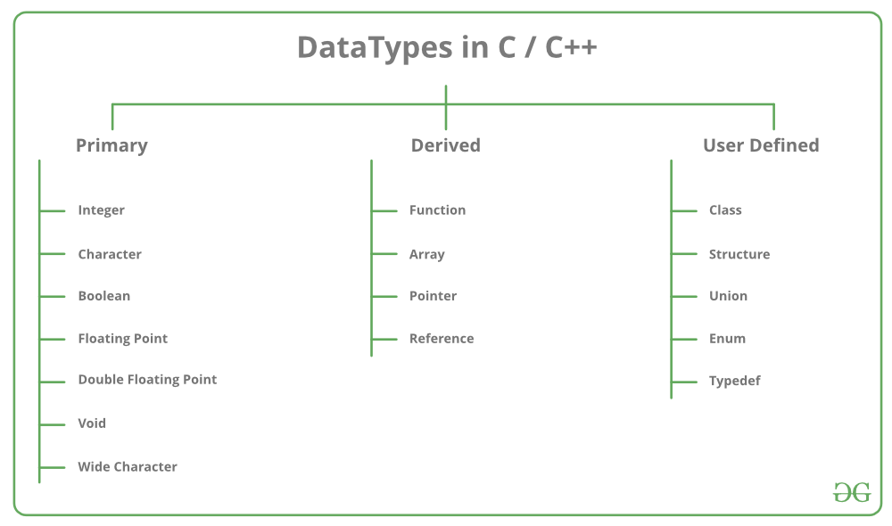
Data Types in C++ are Mainly Divided into 3 Types:
1. Primitive Data Types: These data types are built-in or predefined data types and can be used directly by the user to declare variables. example: int, char, float, bool, etc. Primitive data types available in C++ are:
- Integer
- Character
- Boolean
- Floating Point
- Double Floating Point
- Valueless or Void
- Wide Character
2. Derived Data Types: Derived data types that are derived from the primitive or built-in datatypes are referred to as Derived Data Types. These can be of four types namely:
- Function
- Array
- Pointer
- Reference
3. Abstract or User-Defined Data Types: Abstract or User-Defined data types are defined by the user itself. Like, defining a class in C++ or a structure. C++ provides the following user-defined datatypes:
- Class
- Structure
- Union
- Enumeration
- Typedef defined Datatype
Primitive Data Types
- Integer: The keyword used for integer data types is int. Integers typically require 4 bytes of memory space and range from -2147483648 to 2147483647.
- Character: Character data type is used for storing characters. The keyword used for the character data type is char. Characters typically require 1 byte of memory space and range from -128 to 127 or 0 to 255.
- Boolean: Boolean data type is used for storing Boolean or logical values. A Boolean variable can store either true or false. The keyword used for the Boolean data type is bool.
- Floating Point: Floating Point data type is used for storing single-precision floating-point values or decimal values. The keyword used for the floating-point data type is float. Float variables typically require 4 bytes of memory space.
- Double Floating Point: Double Floating Point data type is used for storing double-precision floating-point values or decimal values. The keyword used for the double floating-point data type is double. Double variables typically require 8 bytes of memory space.
- void: Void means without any value. void data type represents a valueless entity. A void data type is used for those function which does not return a value.
- Wide Character: Wide character data type is also a character data type but this data type has a size greater than the normal 8-bit data type. Represented by wchar_t. It is generally 2 or 4 bytes long.
- sizeof() operator: sizeof() operator is used to find the number of bytes occupied by a variable/data type in computer memory.
Example:
int m , x[50];
cout<<sizeof(m); //returns 4 which is the number of bytes occupied by the integer variable “m”.
cout<<sizeof(x); //returns 200 which is the number of bytes occupied by the integer array variable “x”.
The size of variables might be different from those shown in the above table, depending on the compiler and the computer you are using.
C++
Explain
// C++ Program to Demonstrate the correct size
// of various data types on your computer.
#include <iostream>
using namespace std;

int main()
{
cout << "Size of char : " << sizeof(char) << endl;
cout << "Size of int : " << sizeof(int) << endl;

cout << "Size of long : " << sizeof(long) << endl;
cout << "Size of float : " << sizeof(float) << endl;

cout << "Size of double : " << sizeof(double) << endl;

return 0;
}
Output
Size of char : 1
Size of int : 4
Size of long : 8
Size of float : 4
Size of double : 8

Time Complexity: O(1)
Space Complexity: O(1)
Datatype Modifiers
As the name suggests, datatype modifiers are used with built-in data types to modify the length of data that a particular data type can hold.
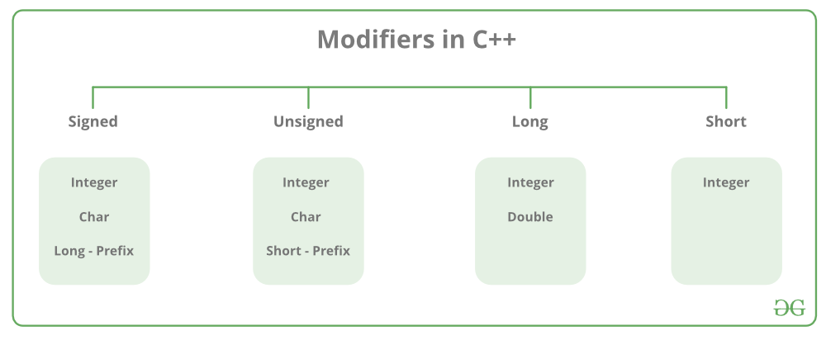
Data type modifiers available in C++ are:
- Signed
- Unsigned
- Short
- Long
The below table summarizes the modified size and range of built-in datatypes when combined with the type modifiers:
Data Type | Size (in bytes) | Range
short int | 2 | -32,768 to 32,767
unsigned short int | 2 | 0 to 65,535
unsigned int | 4 | 0 to 4,294,967,295
int | 4 | -2,147,483,648 to 2,147,483,647
long int | 4 | -2,147,483,648 to 2,147,483,647
unsigned long int | 4 | 0 to 4,294,967,295
long long int | 8 | -(2^63) to (2^63)-1
unsigned long long int | 8 | 0 to 18,446,744,073,709,551,615
signed char | 1 | -128 to 127
unsigned char | 1 | 0 to 255
float | 4 | -3.4×10^38 to 3.4×10^38
double | 8 | -1.7×10^308 to1.7×10^308
long double | 12 | -1.1×10^4932 to1.1×10^4932
wchar_t | 2 or 4 | 1 wide character
Note: Above values may vary from compiler to compiler. In the above example, we have considered GCC 32 bit.We can display the size of all the data types by using the sizeof() operator and passing the keyword of the datatype, as an argument to this function as shown below:
Now to get the range of data types refer to the following chart
Note: syntax<limits.h> header file is defined to find the range of fundamental data-types. Unsigned modifiers have minimum value is zero. So, no macro constants are defined for the unsigned minimum value.
Macro Constants
Name | Expresses
CHAR_MIN | The minimum value for an object of type char
CHAR_MAX | Maximum value for an object of type char
SCHAR_MIN | The minimum value for an object of type Signed char
SCHAR_MAX | Maximum value for an object of type Signed char
UCHAR_MAX | Maximum value for an object of type Unsigned char
CHAR_BIT | Number of bits in a char object
MB_LEN_MAX | Maximum number of bytes in a multi-byte character
SHRT_MIN | The minimum value for an object of type short int
SHRT_MAX | Maximum value for an object of type short int
USHRT_MAX | Maximum value for an object of type Unsigned short int
INT_MIN | The minimum value for an object of type int
INT_MAX | Maximum value for an object of type int
UINT_MAX | Maximum value for an object of type Unsigned int
LONG_MIN | The minimum value for an object of type long int
LONG_MAX | Maximum value for an object of type long int
ULONG_MAX | Maximum value for an object of type Unsigned long int
LLONG_MIN | The minimum value for an object of type long long int
LLONG_MAX | Maximum value for an object of type long long int
ULLONG_MAX | Maximum value for an object of type Unsigned long long int
The actual value depends on the particular system and library implementation but shall reflect the limits of these types in the target platform. LLONG_MIN, LLONG_MAX, and ULLONG_MAX are defined for libraries complying with the C standard of 1999 or later (which only includes the C++ standard since 2011: C++11).
C++ Program to Find the Range of Data Types using Macro Constants
Example:
C++
Explain
// C++ program to Demonstrate the sizes of data types
#include <iostream>
#include <limits.h>
using namespace std;

int main()
{
cout << "Size of char : " << sizeof(char) << " byte"
<< endl;

cout << "char minimum value: " << CHAR_MIN << endl;

cout << "char maximum value: " << CHAR_MAX << endl;

cout << "Size of int : " << sizeof(int) << " bytes"
<< endl;

cout << "Size of short int : " << sizeof(short int)
<< " bytes" << endl;

cout << "Size of long int : " << sizeof(long int)
<< " bytes" << endl;

cout << "Size of signed long int : "
<< sizeof(signed long int) << " bytes" << endl;

cout << "Size of unsigned long int : "
<< sizeof(unsigned long int) << " bytes" << endl;

cout << "Size of float : " << sizeof(float) << " bytes"
<< endl;

cout << "Size of double : " << sizeof(double)
<< " bytes" << endl;

cout << "Size of wchar_t : " << sizeof(wchar_t)
<< " bytes" << endl;

return 0;
}
Output
Size of char : 1 byte
char minimum value: -128
char maximum value: 127
Size of int : 4 bytes
Size of short int : 2 bytes
Size of long int : 8 bytes
Size of signed long int : 8 bytes
Size of unsigned long int : 8 bytes
Size of float : 4 bytes
Size of double : 8 bytes
Size of wchar_t : 4 bytes
Time Complexity: O(1)
Space Complexity: O(1)
C++
Explain
#include <iostream>
#include <string>
using namespace std;

int main() {
// Integer data types
int a = 10;
short b = 20;
long c = 30;
long long d = 40;
cout << "Integer data types: " << endl;
cout << "int: " << a << endl;
cout << "short: " << b << endl;
cout << "long: " << c << endl;
cout << "long long: " << d << endl;

// Floating-point data types
float e = 3.14f;
double f = 3.141592;
long double g = 3.14159265358979L;
cout << "Floating-point data types: " << endl;
cout << "float: " << e << endl;
cout << "double: " << f << endl;
cout << "long double: " << g << endl;

// Character data types
char h = 'a';
wchar_t i = L'b';
char16_t j = u'c';
char32_t k = U'd';
cout << "Character data types: " << endl;
cout << "char: " << h << endl;
wcout << "wchar_t: " << i << endl;
cout << "char16_t: " << j << endl;
cout << "char32_t: " << k << endl;

// Boolean data type
bool l = true;
bool m = false;
cout << "Boolean data type: " << endl;
cout << "true: " << l << endl;
cout << "false: " << m << endl;

// String data type
string n = "Hello, world!";
cout << "String data type: " << endl;
cout << n << endl;

return 0;
}
Output
Integer data types:
int: 10
short: 20
long: 30
long long: 40
Floating-point data types:
float: 3.14
double: 3.14159
long double: 3.14159
Character data types:
char: a
wchar_t: b
char16_t: 99
char32_t: 100
Boolean data type:
true: 1
false: 0
String data type:
Hello, world!
- This program declares variables of various data types, assigns values to them, and then prints out their values.
- The integer data types include int, short, long, and long long. These data types represent whole numbers of varying sizes.
- The floating-point data types include float, double, and long double. These data types represent real numbers with varying levels of precision.
- The character data types include char, wchar_t, char16_t, and char32_t. These data types represent individual characters of varying sizes.
- The boolean data type is a simple data type that can only have one of two values: true or false.
- The string data type is a sequence of characters. In this program, we use the string class to declare a string variable and assign it a value.
Advantages:
- Data types provide a way to categorize and organize data in a program, making it easier to understand and manage.
- Each data type has a specific range of values it can hold, allowing for more precise control over the type of data being stored.
- Data types help prevent errors and bugs in a program by enforcing strict rules about how data can be used and manipulated.
- C++ provides a wide range of data types, allowing developers to choose the best type for a specific task.
Disadvantages:
- Using the wrong data type can result in unexpected behavior and errors in a program.
- Some data types, such as long doubles or char arrays, can take up a large amount of memory and impact performance if used excessively.
- C++’s complex type system can make it difficult for beginners to learn and use the language effectively.
- The use of data types can add additional complexity and verbosity to a program, making it harder to read and understand.

1.Literals In C++
In C++ programming language, we use literals to represent fixed values. C++ supports various types of literals including integer literals, floating-point literals, character literals, and string literals. In this article, we will discuss all the necessary information on C++ literals and their usage.
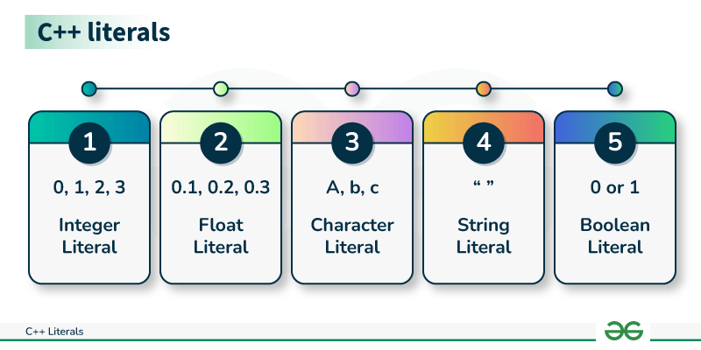
What are Literals in C++?
Literals are fundamental elements used to represent constant values used in C++ programming language. These constants can include numbers, characters, strings, and more. Understanding and using the literals is essential in C++ for data assignment, calculations, and data representation. They are generally present as the right operand in the assignment operation.
Types of Literals in C++
There are five types of literals in C++ which are:
- Integer Literals
- Floating Point Literals
- Character Literals
- String Literals
- Boolean Literals
1. Integer Literals
Integer literals in C++ are constants that represent whole numbers without the fractional or decimal part. They can be positive or negative and can have different bases such as decimal, octal, or hexadecimal.
Example
int integerLiteral = 42;
Implementation
- C++
// C++ Proram to illustrate the use of integer literals
#include <iostream>
using namespace std;

int main()
{

int age = 35; // An integer literal
cout << "Age: " << age << endl;
return 0;
}
Output
Age: 35

In C++, integer literals can be categorized into various types based on their bases.
1. Decimal Literal (No Prefix)
The decimal literal represents an integer in base 10 without any prefix.
Example
int decimal = 42;
2. Octal Literal (Prefix: 0)
The octal literal represents an integer in base 8 and is preceded by the 0 prefix.
Example
int octal = 052; // 42 in decimal
3. Hexadecimal Literal (Prefix: 0x or 0X)
The hexadecimal literal represents an integer in the base 16 and is preceded by either 0x or 0X prefix.
Example
int hexadecimal = 0x2A; // 42 in decimal
4. Binary Literal (Suffix: b or B)
The binary literal represents an integer in the base 2 and can have a suffix of b or B.
Example
int binary = 0b101010; // 42 in decimal
5. Long Integer Literal (Suffix: l or L)
The long integer literal can be suffixed with the l or L to indicate that it is of type long int.
Example
long int longInteger = 42L;
6. Unsigned Integer Literal (Suffix: u or U)
The unsigned integer literal can be suffixed with the u or U to indicate that it is of type unsigned int.
Example
unsigned int unsignedInt = 42U;
7. Long Long Integer Literal (Suffix: ll or LL)
The long long integer literal can be suffixed with the ll or LL to indicate that it is of type long long int.
Example
long long int longLongInteger = 42LL;
2. Floating-Point Literals
The Floating-point literals in C++ are constants that represent numbers with the fractional or decimal part. These can be either single-precision or double-precision values.
Like integer literals, the floating point literals can also be defined as double or float by using suffix (no suffix) and f respectively. By default, all the fractional numbers are considered to be of type double by C++ compiler.
Example
double floatLiteral = 3.14;
Implementation
- C++
// C++ program to illustrate the floating point literals
#include <iostream>
using namespace std;

int main()
{
// float literal
float e = 2.7f;

// double literal
double pi = 3.14;

// long double literal
long double g = 9.8L;

cout << "The Value of pi: " << pi << endl;
cout << "The value of e: " << e << endl;
cout << "The value of g: " << g << endl;
return 0;
}
Output
The Value of pi: 3.14
The value of e: 2.7
The value of g: 9.8

3. Character Literals
The Character literals in C++ are constants that represent individual characters or escape sequences. They are enclosed in single quotes and you can use them to represent the single character.
Example
char charLiteral = 'A';
Implementation
- C++
// C++ program to illustrate the use of charater literal
#include <iostream>
using namespace std;

int main()
{
char grade = 'A';

cout << "Grade: " << grade << endl;
return 0;
}
Output
Grade: A

4. String Literals
The String literals in C++ are constants that represent sequences of the characters. They are enclosed in double quotes and you can use them to represent text or character sequences.
Example
const char* stringLiteral = "Hello, World!";
Implementation
- C++
// C++ program to illustrate the string literals
#include <iostream>
using namespace std;

int main()
{
const char* message = "Hello, GeeksforGeeks!";
cout << "Message: " << message << endl;
return 0;
}
Output
Message: Hello, GeeksforGeeks!

Note: The string literals are the only literals that are not rvalues.
5. Boolean Literals
The Boolean literals represent the truth values and have only two possible values: true and false. These values are used in the Boolean expressions and logic operations.
Example
- C++
// C++ program to illustrate the use of boolean literal
#include <iostream>
using namespace std;

int main()
{
// using boolean literals
bool isTrue = true;
bool isFalse = false;

if (isTrue) {
cout << "isTrue is true" << endl;
}
else {
cout << "isTrue is false" << endl;
}

if (isFalse) {
cout << "isFalse is true" << endl;
}
else {
cout << "isFalse is false" << endl;
}
return 0;
}
Output
isTrue is true
isFalse is false

2.Derived Data Types in C++
Data types are means to identify the type of data and associated operations of handling it. There are three types of data types:
- Pre-defined Data Types
- Derived Data Types
- User-defined Data Types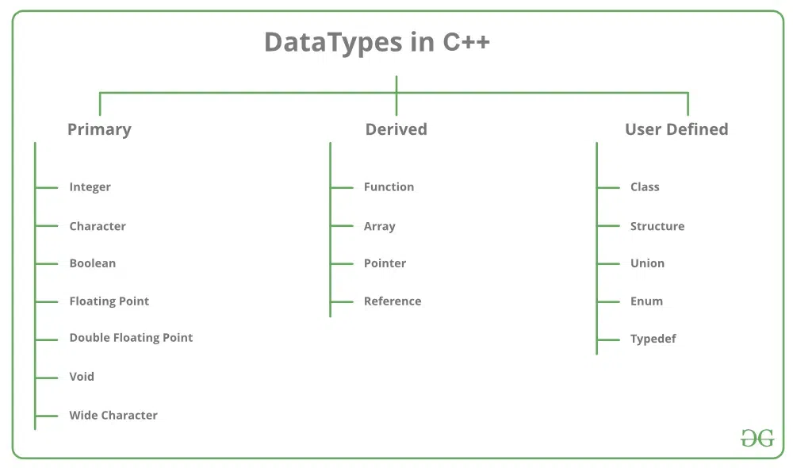
- In this article, the Derived Data Type is explained:
Derived Data Types in C++
The data types that are derived from the primitive or built-in datatypes are referred to as Derived Data Types. These can be of four types namely:
- Function
- Array
- Pointers
- References
Let’s briefly understand each of the following derived datatypes:
1. Function
A Function is a block of code or program segment that is defined to perform a specific well-defined task. A function is generally defined to save the user from writing the same lines of code again and again for the same input. All the lines of code are put together inside a single function and this can be called anywhere required. main() is a default function that is defined in every program of C++.
Syntax
FunctionType FunctionName(parameters)
Example:
The below example demonstrates the use of function in C++.
CPP
Explain
// C++ program to demonstrate
// Function Derived Type

#include <iostream>
using namespace std;

// max here is a function derived type
int max(int x, int y)
{
if (x > y)
return x;
else
return y;
}

// main is the default function derived type
int main()
{
int a = 10, b = 20;

// Calling above function to
// find max of 'a' and 'b'
int m = max(a, b);

cout << "m is " << m;
return 0;
}
Output
m is 20
Explanation: This above program demonstrates the use of function derived types It defines a function called ‘max’ this function returns the maximum of two integers provided as input. In the main function, max function is called to find the maximum of variables ‘a’ and ‘b’ and store it in m and finally print m(max number).
2. Array
An Array is a collection of items stored at continuous memory locations. The idea of array is to represent many instances in one variable.
Syntax
DataType ArrayName[size_of_array];
Example:
The below example demonstrates the use of array in C++.
CPP
Explain
// C++ program to demonstrate
// Array Derived Type

#include <iostream>
using namespace std;
int main()
{

// Array Derived Type
int arr[5];
arr[0] = 5;
arr[2] = -10;

// this is same as arr[1] = 2
arr[3 / 2] = 2;

arr[3] = arr[0];

cout << arr[0] << " " << arr[1] << " " << arr[2] << " "
<< arr[3];

return 0;
}
Output
5 2 -10 5
Explanation: This above program shows the use of array-derived type. It creates an integer array ‘arr’ and assigns values using indices. Then it prints all the array elements.
3. Pointers
Pointers are symbolic representation of addresses. They enable programs to simulate call-by-reference as well as to create and manipulate dynamic data structures. It’s general declaration in C/C++ has the format:
Syntax
datatype *var_name;
for example: int *ptr; (ptr points to an addresswhich holds int data).
Example:
The below example demonstrates the use of pointer in C++.
CPP
Explain
// C++ program to illustrate
// Pointers Derived Type
#include <iostream>
using namespace std;

void geeks()
{
int var = 20;

// Pointers Derived Type
// declare pointer variable
int* ptr;

// note that data type of ptr
// and var must be same
ptr = &var;

// assign the address of a variable
// to a pointer
cout << "Value at ptr = " << ptr << "\n";
cout << "Value at var = " << var << "\n";
cout << "Value at *ptr = " << *ptr << "\n";
}

// Driver program
int main() { geeks(); }
Output
Value at ptr = 0x7ffc04f3f894
Value at var = 20
Value at *ptr = 20
Explanation: This above program demonstrates the use of pointers as a derived type. It deca pointer variable ‘ptr’ and assigning the address of a variable ‘var’ to it. It then prints the values of the pointer, the variable, and the dereferenced pointer, showcasing the basics of pointer usage in C++.
4. Reference
When a variable is declared as reference, it becomes an alternative name for an existing variable. A variable can be declared as reference by putting ‘&’ in the declaration.
Syntax
data_type &ref = variable;
Example:
The below example demonstrates the use of reference in C++.
CPP
Explain
// C++ program to illustrate
// Reference Derived Type

#include <iostream>
using namespace std;

int main()
{
int x = 10;

// Reference Derived Type
// ref is a reference to x.
int& ref = x;

// Value of x is now changed to 20
ref = 20;
cout << "x = " << x << endl;

// Value of x is now changed to 30
x = 30;
cout << "ref = " << ref << endl;

return 0;
}
Output
x = 20
ref = 30
Explanation: The above program demonstrates the use of reference-derived type. A reference ‘ref’ to an integer variable ‘x. is created’. If the value of ‘ref’ is changed the value ‘x,’ is also modified and vice versa.
Conclusion
Derived data types in C++ are functions, arrays, pointers, and references offer so many useful tools to handle data. Functions let us write the reusable code. Arrays help manage multiple items and data very efficiently. Pointers allows the flexible memory use and also referencing. References provide a way to create alias and simpler ways to work with variables. Overall, these derived datatypes make C++ coding more systematic and effective.

3.User Defined Data Types in C++
Data types are means to identify the type of data and associated operations of handling it. improve. In C++ datatypes are used to declare the variable. There are three types of data types:
- Pre-defined DataTypes
- Derived Data Types
- User-defined DataTypes

In this article, the User-Defined DataType is explained:
User-Defined DataTypes
The data types that are defined by the user are called the derived datatype or user-defined derived data type. These types include:
- Class
- Structure
- Union
- Enumeration
- Typedef
Below is a detailed description of the following types:
1. Class
A Class is the building block of C++ that leads to Object-Oriented programming is a Class. It is a user-defined data type, which holds its own data members and member functions, which can be accessed and used by creating an instance of that class. A class is like a blueprint for an object.
Syntax
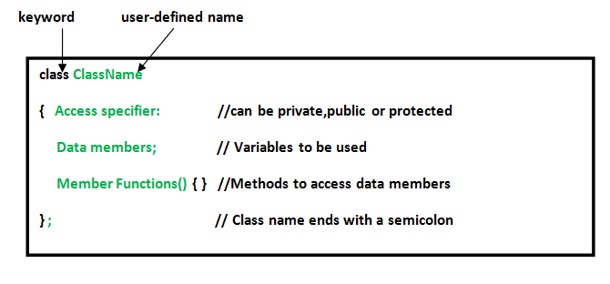Example:
The below example demonstrates the use of class in C++.
- CPP
// C++ program to demonstrate
// Class

#include <bits/stdc++.h>
using namespace std;

class Geeks {
// Access specifier
public:
// Data Members
string geekname;

// Member Functions()
void printname()
{
cout << "Geekname is: " << geekname;
}
};

int main()
{

// Declare an object of class geeks
Geeks obj1;

// accessing data member
obj1.geekname = "GeeksForGeeks";

// accessing member function
obj1.printname();

return 0;
}
Output
Geekname is: GeeksForGeeks
Explanation: The above program defines a class named “Geeks” with a geekname attribute and a function printname() to print the geek’s name. In the main function, it creates an object named obj1, sets the geekname as “GeeksforGeeks”, and calls the printname() function to display it.
2. Structure
A Structure is a user-defined data type in C/C++. A structure creates a data type that can be used to group items of possibly different types into a single type.
Syntax
struct structName{
char varName[size];
int varName;
};
Example:
The below example demonstrates the use of structures in C++.
- CPP
// C++ program to demonstrate
// Structures in C++

#include <iostream>
using namespace std;

// declaring structure
struct Point {
int x, y;
};

int main()
{
// Create an array of structures
struct Point arr[10];

// Access array members
arr[0].x = 10;
arr[0].y = 20;

cout << arr[0].x << ", " << arr[0].y;

return 0;
}
Output
10, 20
Explanation: The above demonstrates program demonstrates the use of structures by defining a structure named “Points” having x and y coordinates. It creates an array of these structures in the main function, sets their values, and prints them.
3. Union
Like Structures , Union a user-defined data type. In union, all members share the same memory location. For example in the following C program, both x and y share the same location. If we change x, we can see the changes being reflected in y.
Syntax
Union_Name
{
// Declaration of data members
}; union_variables;
Example:
The below example demonstrates the use of union in C++.
- CPP
#include <iostream>
using namespace std;

// Declaration of union is same as the structures
union test {
int x, y;
};

int main()
{
// A union variable t
union test t;

// t.y also gets value 2
t.x = 2;

cout << "After making x = 2:" << endl
<< "x = " << t.x << ", y = " << t.y << endl;

// t.x is also updated to 10
t.y = 10;

cout << "After making Y = 10:" << endl
<< "x = " << t.x << ", y = " << t.y << endl;

return 0;
}
Output
After making x = 2:
x = 2, y = 2
After making Y = 10:
x = 10, y = 10
Explanation: The above program demonstrates the use of unions. Union named “test” with integer members x and y is defined, here x and y shares the same memory space. In the main function value of x is set to 2 and then printed. Later, it updates y to 10 and the value of x is also updated to 10, this shows the shared memory characteristic of unions.
4. Enumeration
Enumeration (or enum) is a user-defined data type in C. It is mainly used to assign names to integral constants, the names make a program easy to read and maintain.
Syntax
enum nameOfEnum {
varName1 = 1, varName2 = 0
};
Example:
The below example demonstrates the use of enumeration (enum) in C++.
- C++
// Program to demonstrate working
// of enum in C++

#include <iostream>
using namespace std;

enum week { Mon, Tue, Wed, Thur, Fri, Sat, Sun };

int main()
{
enum week day;

day = Wed;

cout << day;

return 0;
}
Output
2
5. Typedef
C++ allows you to define explicitly new data type names by using the keyword typedef. Using typedef does not create a new data class, rather it defines a name for an existing type. This can increase the portability(the ability of a program to be used across different types of machines; i.e., mini, mainframe, micro, etc; without many changes to the code)of a program as only the typedef statements would have to be changed. Using typedef one can also aid in self-documenting code by allowing descriptive names for the standard data types.
Syntax
typedef typeName;
where typeName is any C++ data type and name is the new name for this data type. This defines another name for the standard type of C++.
Example:
The below program demonstrates the type def in C++.
- CPP
// C++ program to demonstrate typedef
#include <iostream>
using namespace std;

// After this line BYTE can be used
// in place of unsigned char
typedef unsigned char BYTE;

int main()
{
BYTE b1, b2;
b1 = 'c';
cout << " " << b1;
return 0;
}
Output
c
Conclusion
In conclusion, C++ has user-defined data types, like classes, structures, unions, enumerations, and typedefs. These user-defined datatypes allow the programmers to easily organize and customize their code, and write modular, efficient, and readable code. Hence, User-defined data types improve the flexibility and structure of C++ programs for better code organization.

4.C++ Type Modifiers
Modifiers are used in C++ to change or give extra meaning to already existing data types. It’s added to primitive data types as a prefix to change their meaning. A modifier is used to change the meaning of a basic type so that it better matches the requirements of different circumstances.
Following are the C++ data type modifiers:
- signed
- unsigned
- short
- long

These modifiers can be used with the following Built-in Data Types.
1. signed Modifier
Signed variables can store positive, negative integers, and zero.
Example:
signed int a = 45;
signed int b = -67;
signed int c = 0;
Here,
- ‘a’ is a positive valued integer.
- ‘b’ is a negative valued integer.
- ‘c’ is a zero-valued integer.
Example:
C++
Explain
// C++ program to demonstrate
// the signed modifier
#include <iostream>
using namespace std;

// Driver Code
int main()
{
cout << "Size of signed int : " <<
sizeof(signed int) <<
" bytes" << endl;
cout << "Size of signed char : " <<
sizeof(signed char) <<
" bytes" << endl;

return 0;
}
Output
Size of signed int : 4 bytes
Size of signed char : 1 bytes
Note: The int datatype is signed by default. So, int can be directly be used instead of signed int.
2. unsigned Modifier
Unsigned variables can store only non-negative integer values.
Example:
unsigned int a = 9;
unsigned int b = 0;
Here,
- ‘a’ is a positive valued integer.
- ‘b’ is a zero-valued integer.
Example:
C++
Explain
// C++ program to demonstrate
// the unsigned modifier
#include <iostream>
using namespace std;

// Driver Code
int main()
{
cout << "Size of unsigned int : " <<
sizeof(unsigned int) <<
" bytes" << endl;
cout << "Size of unsigned char : " <<
sizeof(unsigned char) <<
" bytes" << endl;
return 0;
}
Output
Size of unsigned int : 4 bytes
Size of unsigned char : 1 bytes
Difference Between Signed and Unsigned Modifiers
- The signed value of the signed variable is stored in the allocated memory. However, the signed value is not stored by the unsigned variables.
- Signed integers use one bit to represent the sign (positive or negative), whereas unsigned integers use all the bits to represent a non-negative value.
- The range of values for unsigned types starts from 0. For example, for unsigned int, the value range is from 0 to 4,294,967,295. However, for signed int, the value range is from -2,147,483,648 to 2,147,483,647.
Note: signed and unsigned modifiers can only be used with int and char datatypes.
3. short Modifier
The short keyword modifies the minimum values that a data type can hold. It is used for small integers that lie in the range of −32,767 to +32,767.
Example:
short int x = 4590;
Example:
C++
Explain
// C++ program to demonstrate
// the short modifier
#include <iostream>
using namespace std;

// Driver Code
int main()
{
cout << "Size of short int : " <<
sizeof(short int) <<
" bytes" << endl;
return 0;
}
Output
Size of short int : 2 bytes
Note: The short int can be written as short also. They are equivalent.
4. long Modifier
The long keyword modifies the maximum values that a data type can hold. It is used for large integers that are in the range of -2147483647 to 2147483647.
Example:
long int y = 26936;
Example:
C++
Explain
// C++ program to demonstrate
// the long modifier
#include <iostream>
using namespace std;

// Driver Code
int main()
{
cout << "Size of long int : " <<
sizeof(long int) <<
" bytes" << endl;
cout << "Size of long double : " <<
sizeof(long double) <<
" bytes" << endl;
return 0;
}
Output
Size of long int : 8 bytes
Size of long double : 16 bytes
Note: The long int can be written as long also. They are equivalent.
Important Points about Data Type Modifiers
1. The modifiers for a data type can be combined.
For example, signed/unsigned can be used with long/short modifiers. Below is the C++ program to demonstrate the above concept.
Example:
C++
Explain
// C++ program to demonstrate
// that modifiers can be combined
// together
#include <iostream>
using namespace std;

// Driver Code
int main()
{
cout << "Size of signed long int : " <<
sizeof(signed long int) <<
" bytes" << endl;
cout << "Size of unsigned short int : " <<
sizeof(unsigned short int) <<
" bytes" << endl;
return 0;
}
Output
Size of signed long int : 8 bytes
Size of unsigned short int : 2 bytes
2. The long modifier can be used as twice as long long.
It is used for even larger numbers than long. However, long long-type modifiers can only be used with int. Below is the C++ program to demonstrate the above concept.
Example:
C++
Explain
// C++ program to demonstrate
// the long long modifier
#include <iostream>
using namespace std;

// Driver Code
int main()
{
cout << "Size of long long int : " <<
sizeof(long long int) <<
" bytes" << endl;
return 0;
}
Output
Size of long long int : 8 bytes
Various Data Types with Modifiers and Their Size in Bytes
1. Character Data Type (char)
Character datatype only allows signed and unsigned modifiers. When only char is used instead of signed char or unsigned char, this type is known as plain char. When performing numerical computations, it is preferred to utilize signed char or unsigned char instead of plain char. Character values should only be stored as plain char.
S No. | Modifier | Size(in Bytes)
1. | char | 1
2. | signed char | 1
3. | unsigned char | 1
2. Integer Data Type (int)
S No. | Modifier | Size(in Bytes)
1. | int | 4
2. | signed int | 4
3. | unsigned int | 4
4. | short | 2
5. | signed short | 2
6. | unsigned short | 2
7. | long | 8
8. | signed long | 8
9. | unsigned long | 8
3. Floating Point (float) and Double Precision Floating Point (double)
Double type can be used with the long modifier.
S No. | Modifier | Size(in Bytes)
1. | float | 4
2. | double | 8
3. | long double | 16
Type Qualifiers in C++:
Type qualifiers are used to provide more information about a value while also guaranteeing that the data is used correctly.
- const: Objects of type const cannot be altered during execution. Const objects cannot be modified by your program while it is running.
- volatile: The modifier volatile tells the compiler that a variable’s value can be changed in ways that are not explicitly defined by the program. The compiler is informed by the modifier volatile that a variable’s value might change in ways that aren’t clearly stated in the program.
- restrict: A pointer qualified by restricting is initially the only means by which the object it points to can be accessed. The object restricts links that can only initially be accessed via a pointer qualified by it. Restrict is a new type of qualifier that is only added in C99.

5.Type Conversion in C++
Type conversion is essential for managing different data types in C++. The C++ Course covers the various methods of type conversion, helping you understand how to handle data types correctly. A type cast is basically a conversion from one type to another. There are two types of type conversion:
- Implicit Type Conversion Also known as ‘automatic type conversion’.
- Done by the compiler on its own, without any external trigger from the user.
- Generally takes place when in an expression more than one data type is present. In such condition type conversion (type promotion) takes place to avoid lose of data.
- All the data types of the variables are upgraded to the data type of the variable with largest data type.
bool -> char -> short int -> int ->

unsigned int -> long -> unsigned ->

long long -> float -> double -> long double
It is possible for implicit conversions to lose information, signs can be lost (when signed is implicitly converted to unsigned), and overflow can occur (when long long is implicitly converted to float).
Example of Type Implicit Conversion:
CPP
Explain
// An example of implicit conversion

#include <iostream>
using namespace std;

int main()
{
int x = 10; // integer x
char y = 'a'; // character c

// y implicitly converted to int. ASCII
// value of 'a' is 97
x = x + y;

// x is implicitly converted to float
float z = x + 1.0;

cout << "x = " << x << endl
<< "y = " << y << endl
<< "z = " << z << endl;

return 0;
}
Output
x = 107
y = a
z = 108
Explicit Type Conversion: This process is also called type casting and it is user-defined. Here the user can typecast the result to make it of a particular data type. In C++, it can be done by two ways:
Converting by assignment: This is done by explicitly defining the required type in front of the expression in parenthesis. This can be also considered as forceful casting.
Syntax:
(type) expression
where type indicates the data type to which the final result is converted.
Example:
CPP
Explain
// C++ program to demonstrate
// explicit type casting

#include <iostream>
using namespace std;

int main()
{
double x = 1.2;

// Explicit conversion from double to int
int sum = (int)x + 1;

cout << "Sum = " << sum;

return 0;
}
Output
Sum = 2
Conversion using Cast operator: A Cast operator is an unary operator which forces one data type to be converted into another data type. C++ supports four types of casting:
- Static Cast
- Dynamic Cast
- Const Cast
- Reinterpret Cast
Example:
CPP
Explain
#include <iostream>
using namespace std;
int main()
{
float f = 3.5;

// using cast operator
int b = static_cast<int>(f);

cout << b;
}
Output
3
Advantages of Type Conversion:
This is done to take advantage of certain features of type hierarchies or type representations.
It helps to compute expressions containing variables of different data types.

6.Casting Operators in C++
Casting operators are used for type casting in C++. They are used to convert one data type to another. C++ supports four types of casts:
- static_cast
- dynamic_cast
- const_cast
- reinterpret_cast
1. static_cast
The static_cast operator is the most commonly used casting operator in C++. It performs compile-time type conversion and is mainly used for explicit conversions that are considered safe by the compiler.
Syntax of static_cast
static_cast <new_type> (expression);
where,
- expression: Data to be converted.
- new_type: Desired type of expression
The static_cast can be used to convert between related types, such as numeric types or pointers in the same inheritance hierarchy.
Example of static_cast
[GFGTABS]
C++
Explain
// C++ program to illustrate the static_cast
#include <iostream>
#include <typeinfo>
using namespace std;

int main()
{

int num = 10;

// converting int to double
double numDouble = static_cast<double>(num);

// printing data type
cout << typeid(num).name() << endl;

// typecasting
cout << typeid(static_cast<double>(num)).name() << endl;

// printing double type t
cout << typeid(numDouble).name() << endl;

return 0;
}
[/GFGTABS]
Output
i
d
d

In this example, we have included the “typeinfo” library so that we can use typeid() function to check the data type. We have defined an integer variable ‘num’ and converted it into a double using static_cast. After that, we print the data types of variables and pass static_cast<double>(num) in typeid() function to check its data type. we can see the output “i, d, d” is printed where ‘i’ denotes integer and ‘d’ denotes double.
2. dynamic_cast
The dynamic_cast operator is mainly used to perform downcasting (converting a pointer/reference of a base class to a derived class). It ensures type safety by performing a runtime check to verify the validity of the conversion.
Syntax of dynamic_cast
dynamic_cast <new_type> (expression);
If the conversion is not possible, dynamic_cast returns a null pointer (for pointer conversions) or throws a bad_cast exception (for reference conversions).
Example of dynamic_cast
[GFGTABS]
C++
Explain
// C++ program to illustrate the dynamic_cast
#include <iostream>
using namespace std;

// Base Class
class Animal {
public:
virtual void speak() const
{
cout << "Animal speaks." << endl;
}
};

// Derived Class
class Dog : public Animal {
public:
void speak() const override
{
cout << "Dog barks." << endl;
}
};

// Derived Class
class Cat : public Animal {
public:
void speak() const override
{
cout << "Cat meows." << endl;
}
};

int main()
{
// base class pointer to derived class object
Animal* animalPtr = new Dog();

// downcasting
Dog* dogPtr = dynamic_cast<Dog*>(animalPtr);

// checking if the typecasting is successfull
if (dogPtr) {
dogPtr->speak();
}
else {
cout << "Failed to cast to Dog." << endl;
}

// typecasting to other dervied class
Cat* catPtr = dynamic_cast<Cat*>(animalPtr);
if (catPtr) {
catPtr->speak();
}
else {
cout << "Failed to cast to Cat." << endl;
}

delete animalPtr;
return 0;
}
[/GFGTABS]
Output
Dog barks.
Failed to cast to Cat.
Explanation: The first line of output is printed because the ‘animalPtr’ of the ‘Animal’ type is successfully cast to the ‘Dog’ type and speak() function of the Dog class is invoked but the casting of the ‘Animal’ type to ‘Cat’ type is failed because ‘animalPtr’ points to a ‘Dog’ object thus, the dynamic cast fails because the typecasting is not safe.
3. const_cast
The const_cast operator is used to modify the const or volatile qualifier of a variable. It allows programmers to temporarily remove the constancy of an object and make modifications. Caution must be exercised when using const_cast, as modifying a const object can lead to undefined behavior.
Syntax for const_cast
const_cast <new_type> (expression);
Example of const_cast
[GFGTABS]
C++
Explain
// C++ program to illustrate the const_cast
#include <iostream>
using namespace std;

int main()
{

const int number = 5;
// Pointer to a const int
const int* ptr = &number;

// int* nonConstPtr = ptr; if we use this
// instead of without using const_cast
// we will get error of invalid conversion
int* nonConstPtr = const_cast<int*>(ptr);
*nonConstPtr = 10;

cout << "Modified number: " << *nonConstPtr;

return 0;
}
[/GFGTABS]
Output
Modified number: 10
In the above example, we have modified the value of the const type pointer by changing its qualifier from const to non-const and then printing the modified value.
4. reinterpret_cast
The reinterpret_cast operator is used to convert the pointer to any other type of pointer. It does not perform any check whether the pointer converted is of the same type or not.
Syntax of reinterpret_cast
reinterpret_cast <new_type> (expression);
Example
[GFGTABS]
C++
Explain
// C++ program to illustrate the reinterpret_cast
#include <iostream>
using namespace std;

int main()
{
int number = 10;
// Store the address of number in numberPointer
int* numberPointer = &number;

// Reinterpreting the pointer as a char pointer
char* charPointer
= reinterpret_cast<char*>(numberPointer);

// Printing the memory addresses and values
cout << "Integer Address: " << numberPointer << endl;
cout << "Char Address: "
<< reinterpret_cast<void*>(charPointer) << endl;

return 0;
}
[/GFGTABS]
Output
Integer Address: 0x7fff64789f1c
Char Address: 0x7fff64789f1c

In the above example, we have defined an int variable ‘number’ and then store the address of ‘number’ in ‘numberPointer’ of the int type after that we have converted the ‘numberPointer’ of the int type into char pointer and then store it into ‘charPointer’ variable. To verify that we have printed the address of both numberPointer and charPointer. To print the address stored in ‘charPointer’ reinterpret_cast<void*> is used to bypass the type-checking mechanism of C++ and allow the pointer to be printed as a generic memory address without any type-specific interpretation.
Note: const_cast and reinterpret_cast are generally not reccommended as they vulnerable to different kinds of errors.

Operators in C++
An operator is a symbol that operates on a value to perform specific mathematical or logical computations. They form the foundation of any programming language. In C++, we have built-in operators to provide the required functionality.
An operator operates the operands. For example,
int c = a + b;
Here, ‘+’ is the addition operator. ‘a’ and ‘b’ are the operands that are being ‘added’.
Operators in C++ can be classified into 6 types:
- Arithmetic Operators
- Relational Operators
- Logical Operators
- Bitwise Operators
- Assignment Operators
- Ternary or Conditional Operators
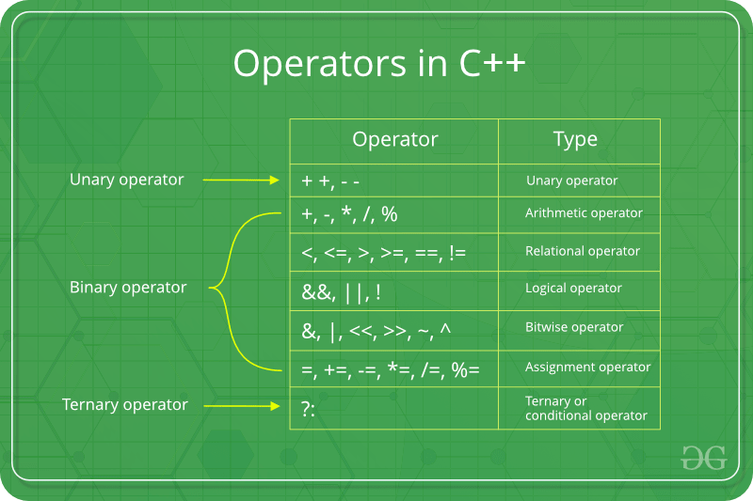
1) Arithmetic Operators
These operators are used to perform arithmetic or mathematical operations on the operands. For example, ‘+’ is used for addition, ‘-‘ is used for subtraction ‘*’ is used for multiplication, etc.
Arithmetic Operators can be classified into 2 Types:
A) Unary Operators: These operators operate or work with a single operand. For example: Increment(++) and Decrement(–) Operators.
Name | Symbol | Description | Example
Increment Operator | ++ | Increases the integer value of the variable by one | int a = 5;  a++; // returns 6
Decrement Operator | — | Decreases the integer value of the variable by one | int a = 5;  a–; // returns 4
Example:
the description
Output
a++ is 10
++a is 12
b-- is 15
--b is 13
TimeComplexity:O(1)
Auxiliary Space : O(1)
Note: ++a and a++, both are increment operators, however, both are slightly different.
In ++a, the value of the variable is incremented first and then It is used in the program. In a++, the value of the variable is assigned first and then It is incremented. Similarly happens for the decrement operator.
B) Binary Operators: These operators operate or work with two operands. For example: Addition(+), Subtraction(-), etc.
Name | Symbol | Description | Example
Addition | + | Adds two operands | int a = 3, b = 6;  int c = a+b; // c = 9
Subtraction | – | Subtracts second operand from the first | int a = 9, b = 6;  int c = a-b; // c = 3
Multiplication | * | Multiplies two operands | int a = 3, b = 6;  int c = a*b; // c = 18
Division | / | Divides first operand by the second operand | int a = 12, b = 6;  int c = a/b; // c = 2
Modulo Operation | % | Returns the remainder an integer division | int a = 8, b = 6;  int c = a%b; // c = 2
Note: The Modulo operator(%) operator should only be used with integers.
Example:
C++
Explain
// CPP Program to demonstrate the Binary Operators
#include <iostream>
using namespace std;

int main()
{
int a = 8, b = 3;

// Addition operator
cout << "a + b = " << (a + b) << endl;

// Subtraction operator
cout << "a - b = " << (a - b) << endl;

// Multiplication operator
cout << "a * b = " << (a * b) << endl;

// Division operator
cout << "a / b = " << (a / b) << endl;

// Modulo operator
cout << "a % b = " << (a % b) << endl;

return 0;
}
Output
a + b = 11
a - b = 5
a * b = 24
a / b = 2
a % b = 2
TimeComplexity:O(1)
Auxiliary Space : O(1)
2) Relational Operators
These operators are used for the comparison of the values of two operands. For example, ‘>’ checks if one operand is greater than the other operand or not, etc. The result returns a Boolean value, i.e., true or false.
Name | Symbol | Description | Example
Is Equal To | == | Checks if both operands are equal | int a = 3, b = 6;  a==b;  // returns false
Greater Than | > | Checks if first operand is greater than the second operand | int a = 3, b = 6;  a>b;  // returns false
Greater Than or Equal To | >= | Checks if first operand is greater than or equal to the second operand | int a = 3, b = 6;  a>=b;  // returns false
Less Than | < | Checks if first operand is lesser than the second operand | int a = 3, b = 6;  a<b;  // returns true
Less Than or Equal To | <= | Checks if first operand is lesser than or equal to the second operand | int a = 3, b = 6;  a<=b;  // returns true
Not Equal To | != | Checks if both operands are not equal | int a = 3, b = 6;  a!=b;  // returns true
Example:
C++
Explain
// CPP Program to demonstrate the Relational Operators
#include <iostream>
using namespace std;

int main()
{
int a = 6, b = 4;

// Equal to operator
cout << "a == b is " << (a == b) << endl;

// Greater than operator
cout << "a > b is " << (a > b) << endl;

// Greater than or Equal to operator
cout << "a >= b is " << (a >= b) << endl;

// Lesser than operator
cout << "a < b is " << (a < b) << endl;

// Lesser than or Equal to operator
cout << "a <= b is " << (a <= b) << endl;

// true
cout << "a != b is " << (a != b) << endl;

return 0;
}
Output
a == b is 0
a > b is 1
a >= b is 1
a < b is 0
a <= b is 0
a != b is 1
TimeComplexity:O(1)
Auxiliary Space : O(1)
Here, 0 denotes false and 1 denotes true. To read more about this, please refer to the article – Relational Operators.
3) Logical Operators
These operators are used to combine two or more conditions or constraints or to complement the evaluation of the original condition in consideration. The result returns a Boolean value, i.e., true or false.
Name | Symbol | Description | Example
Logical AND | && | Returns true only if all the operands are true or non-zero | int a = 3, b = 6;  a&&b;  // returns true
Logical OR | || | Returns true if either of the operands is true or non-zero | int a = 3, b = 6;  a||b;  // returns true
Logical NOT | ! | Returns true if the operand is false or zero | int a = 3;  !a;  // returns false
Example:
C++
Explain
// CPP Program to demonstrate the Logical Operators
#include <iostream>
using namespace std;

int main()
{
int a = 6, b = 4;

// Logical AND operator
cout << "a && b is " << (a && b) << endl;

// Logical OR operator
cout << "a || b is " << (a || b) << endl;

// Logical NOT operator
cout << "!b is " << (!b) << endl;

return 0;
}
Output
a && b is 1
a ! b is 1
!b is 0
TimeComplexity:O(1)
Auxiliary Space : O(1)
Here, 0 denotes false and 1 denotes true. To read more about this, please refer to the article – Logical Operators.
4) Bitwise Operators
These operators are used to perform bit-level operations on the operands. The operators are first converted to bit-level and then the calculation is performed on the operands. Mathematical operations such as addition, subtraction, multiplication, etc. can be performed at the bit level for faster processing.
Name | Symbol | Description | Example
Binary AND | & | Copies a bit to the evaluated result if it exists in both operands | int a = 2, b = 3;  (a & b); //returns 2
Binary OR | | | Copies a bit to the evaluated result if it exists in any of the operand | int a = 2, b = 3;  (a | b); //returns 3
Binary XOR | ^ | Copies the bit to the evaluated result if it is present in either of the operands but not both | int a = 2, b = 3;  (a ^ b); //returns 1
Left Shift | << | Shifts the value to left by the number of bits specified by the right operand. | int a = 2, b = 3;  (a << 1); //returns 4
Right Shift | >> | Shifts the value to right by the number of bits specified by the right operand. | int a = 2, b = 3;  (a >> 1); //returns 1
One’s Complement | ~ | Changes binary digits 1 to 0 and 0 to 1 | int b = 3;  (~b); //returns -4
Note: Only char and int data types can be used with Bitwise Operators.
Example:
C++
Explain
// CPP Program to demonstrate the Bitwise Operators
#include <iostream>
using namespace std;

int main()
{
int a = 6, b = 4;

// Binary AND operator
cout << "a & b is " << (a & b) << endl;

// Binary OR operator
cout << "a | b is " << (a | b) << endl;

// Binary XOR operator
cout << "a ^ b is " << (a ^ b) << endl;

// Left Shift operator
cout << "a<<1 is " << (a << 1) << endl;

// Right Shift operator
cout << "a>>1 is " << (a >> 1) << endl;

// One’s Complement operator
cout << "~(a) is " << ~(a) << endl;

return 0;
}
Output
a & b is 4
a | b is 6
a ^ b is 2
a<<1 is 12
a>>1 is 3
~(a) is -7
TimeComplexity:O(1)
Auxiliary Space : O(1)
To read more about this, please refer to the article – Bitwise Operators.
5) Assignment Operators
These operators are used to assign value to a variable. The left side operand of the assignment operator is a variable and the right side operand of the assignment operator is a value. The value on the right side must be of the same data type as the variable on the left side otherwise the compiler will raise an error.
Namemultiply | Symbol | Description | Example
Assignment Operator | = | Assigns the value on the right to the variable on the left | int a = 2;  // a = 2
Add and Assignment Operator | += | First adds the current value of the variable on left to the value on the right and then assigns the result to the variable on the left | int a = 2, b = 4;  a+=b; // a = 6
Subtract and Assignment Operator | -= | First subtracts the value on the right from the current value of the variable on left and then assign the result to the variable on the left | int a = 2, b = 4;  a-=b; // a = -2
Multiply and Assignment Operator | *= | First multiplies the current value of the variable on left to the value on the right and then assign the result to the variable on the left | int a = 2, b = 4;  a*=b; // a = 8
Divide and Assignment Operator | /= | First divides the current value of the variable on left by the value on the right and then assign the result to the variable on the left | int a = 4, b = 2;  a /=b; // a = 2
Example:
C++
Explain
// CPP Program to demonstrate the Assignment Operators
#include <iostream>
using namespace std;

int main()
{
int a = 6, b = 4;

// Assignment Operator
cout << "a = " << a << endl;

// Add and Assignment Operator
cout << "a += b is " << (a += b) << endl;

// Subtract and Assignment Operator
cout << "a -= b is " << (a -= b) << endl;

// Multiply and Assignment Operator
cout << "a *= b is " << (a *= b) << endl;

// Divide and Assignment Operator
cout << "a /= b is " << (a /= b) << endl;

return 0;
}
Output
a = 6
a += b is 10
a -= b is 6
a *= b is 24
a /= b is 6
TimeComplexity:O(1)
Auxiliary Space : O(1)
6) Ternary or Conditional Operators(?:)
This operator returns the value based on the condition.
Expression1? Expression2: Expression3
The ternary operator ? determines the answer on the basis of the evaluation of Expression1. If it is true, then Expression2 gets evaluated and is used as the answer for the expression. If Expression1 is false, then Expression3 gets evaluated and is used as the answer for the expression.
This operator takes three operands, therefore it is known as a Ternary Operator.
Example:
C++
Explain
// CPP Program to demonstrate the Conditional Operators
#include <iostream>
using namespace std;

int main()
{
int a = 3, b = 4;

// Conditional Operator
int result = (a < b) ? b : a;
cout << "The greatest number is " << result << endl;

return 0;
}
Output
The greatest number is 4
TimeComplexity:O(1)
Auxiliary Space : O(1)
7) There are some other common operators available in C++ besides the operators discussed above. Following is a list of these operators discussed in detail:
A) sizeof Operator: This unary operator is used to compute the size of its operand or variable.
sizeof(char); // returns 1
B) Comma Operator(,): This binary operator (represented by the token) is used to evaluate its first operand and discards the result, it then evaluates the second operand and returns this value (and type). It is used to combine various expressions together.
int a = 6;
int b = (a+1, a-2, a+5); // b = 11
C) -> Operator: This operator is used to access the variables of classes or structures.
cout<<emp->first_name;
D) Cast Operator: This unary operator is used to convert one data type into another.
float a = 11.567;
int c = (int) a; // returns 11
E) Dot Operator(.): This operator is used to access members of structure variables or class objects in C++.
cout<<emp.first_name;
F) & Operator: This is a pointer operator and is used to represent the memory address of an operand.
G) * Operator: This is an Indirection Operator
C++
Explain
// CPP Program to demonstrate the & and * Operators
#include <iostream>
using namespace std;

int main()
{
int a = 6;
int* b;
int c;
// & Operator
b = &a;

// * Operator
c = *b;
cout << " a = " << a << endl;
cout << " b = " << b << endl;
cout << " c = " << c << endl;

return 0;
}
Output
a = 6
b = 0x7ffe8e8681bc
c = 6
H) << Operator: It is called the insertion operator. It is used with cout to print the output.
I) >> Operator: It is called the extraction operator. It is used with cin to get the input.
int a;
cin>>a;
cout<<a;
Time Complexity: O(1)
Auxiliary Space : O(1)
Operator Precedence Chart
Precedence | Operator | Description | Associativity
1. | () | Parentheses (function call) | left-to-right
 | [] | Brackets (array subscript)
 | . | Member selection via object name
 | -> | Member selection via a pointer
 | ++/– | Postfix increment/decrement
2. | ++/– | Prefix increment/decrement | right-to-left
 | +/- | Unary plus/minus
 | !~ | Logical negation/bitwise complement
 | (type) | Cast (convert value to temporary value of type)
 | * | Dereference
 | & | Address (of operand)
 | sizeof | Determine size in bytes on this implementation
3. | *,/,% | Multiplication/division/modulus | left-to-right
4. | +/- | Addition/subtraction | left-to-right
5. | << , >> | Bitwise shift left, Bitwise shift right | left-to-right
6. | < , <= | Relational less than/less than or equal to | left-to-right
 | > , >= | Relational greater than/greater than or equal to | left-to-right
7. | == , != | Relational is equal to/is not equal to | left-to-right
8. | & | Bitwise AND | left-to-right
9. | ^ | Bitwise exclusive OR | left-to-right
10. | | | Bitwise inclusive OR | left-to-right
11. | && | Logical AND | left-to-right
12. | || | Logical OR | left-to-right
13. | ?: | Ternary conditional | right-to-left
14. | = | Assignment | right-to-left
 | += , -= | Addition/subtraction assignment
 | *= , /= | Multiplication/division assignment
 | %= , &= | Modulus/bitwise AND assignment
 | ^= , |= | Bitwise exclusive/inclusive OR assignment
 | <>= | Bitwise shift left/right assignment
15. | , | expression separator | left-to-right

C++ Arithmetic Operator
Arithmetic Operators in C++ are used to perform arithmetic or mathematical operations on the operands. For example, ‘+’ is used for addition, ‘–‘ is used for subtraction, ‘*’ is used for multiplication, etc. In simple terms, arithmetic operators are used to perform arithmetic operations on variables and data; they follow the same relationship between an operator and an operand.
C++ Arithmetic operators are of 2 types:
- Unary Arithmetic Operator
- Binary Arithmetic Operator
1. Binary Arithmetic Operator
These operators operate or work with two operands. C++ provides 5 Binary Arithmetic Operators for performing arithmetic functions:
Operator | Name of the Operators | Operation | Implementation
+ | Addition | Used in calculating the Addition of two operands | x+y
– | Subtraction | Used in calculating Subtraction of two operands | x-y
* | Multiplication | Used in calculating Multiplication of two operands | x*y
/ | Division | Used in calculating Division of two operands | x/y
% | Modulus | Used in calculating Remainder after calculation of two operands | x%y
Example:
- C++
// C++ program to execute all 5
// arithmetic function
#include <iostream>
using namespace std;

int main()
{
int GFG1, GFG2;
GFG1 = 10;
GFG2 = 3;

// printing the sum of GFG1 and GFG2
cout<< "GFG1 + GFG2= " << (GFG1 + GFG2) << endl;

// printing the difference of GFG1 and GFG2
cout << "GFG1 - GFG2 = " << (GFG1 - GFG2) << endl;

// printing the product of GFG1 and GFG2
cout << "GFG1 * GFG2 = " << (GFG1 * GFG2) << endl;

// printing the division of GFG1 by GFG2
cout << "GFG1 / GFG2 = " << (GFG1 / GFG2) << endl;

// printing the modulo of GFG1 by GFG2
cout << "GFG1 % GFG2 = " << (GFG1 % GFG2) << endl;

return 0;
}
Output
GFG1 + GFG2= 13
GFG1 - GFG2 = 7
GFG1 * GFG2 = 30
GFG1 / GFG2 = 3
GFG1 % GFG2 = 1
2. Unary Operator
Operator | Symbol | Operation | Implementation
Decrement Operator | — | Decreases the integer value of the variable by one | –x or x —
Increment Operator | ++ | Increases the integer value of the variable by one | ++x or x++
Example:
- C++
// C++ Program to demonstrate the
// increment and decrement operators
#include <iostream>
using namespace std;

int main()
{
int x = 5;

// This statement Incremented 1
cout << "x++ is " << x++ << endl;

// This statement Incremented 1
// from already Incremented
// statement resulting in
// Incrementing of 2
cout << "++x is " << ++x << endl;

int y = 10;

// This statement Decremented 1
cout << "y-- is " << y-- << endl;

// This statement Decremented 1
// from already Decremented
// statement resulting in
// Decrementing of 2
cout << "--y is " << --y << endl;

return 0;
}
Output
x++ is 5
++x is 7
y-- is 10
--y is 8
In ++x, the variable’s value is first increased/incremented before being utilised in the program.
In x++, a variable’s value is assigned before it is increased/incremented.
Similarly happens for the decrement operator.

Unary Operators In C++
Unary operators in C++ are those operators that work on a single value (operand). They perform operations like changing a value’s sign, incrementing or decrementing it by one, or obtaining its address. Examples include ++ for increment, — for decrement, + for positive values, – for negative values,! for logical negation, and & for retrieving memory addresses. In this article, we will discuss various unary operators available in C++.
Types of Unary Operators in C++
C++ has a total of 8 unary operators which are as follows:
- Increment Operator (++)
- Decrement Operator (–)
- Unary Plus Operator (+)
- Unary Minus Operator (-)
- Logical NOT Operator (!)
- Bitwise NOT Operator (~)
- Addressof Operator (&)
- Indirection Operator (*)
- sizeof Operator
1. Increment Operator (++)
The increment operator is used to increase the value of its operand by 1. It works on the numeric operands and be use used as both prefix and postfix to the operand
Syntax
++ operand
or
operand ++
Example
- C++
#include <iostream>

using namespace std;

int main()
{
int x = 5;

// Increment Operator (++)
cout << "Initial value of x: " << x << endl;
x++; // Increment x by 1
cout << "After x++, x is now: " << x << endl;

// Prefix and Postfix Increment/Decrement
int a = 10;
int b, c;

b = ++a; // Prefix increment: first, increment a, then
// assign to b
c = a++; // Postfix increment: first, assign a to c,
// then increment a

cout << "a: " << a << ", b: " << b << ", c: " << c
<< endl;

return 0;
}
Output
Initial value of x: 5
After x++, x is now: 6
a: 12, b: 11, c: 11
2. Decrement Operator (–)
The decrement operator is used to decrement the value by 1. Just like the increment operator, it can be used as pre-decrement and post-decrement. It works on numeric values.
Syntax
operand --
or
-- operand
Example
- C++
// C++ program to illustrate the decrement operator
#include <iostream>
using namespace std;

int main()
{

int var = 10;
cout << "Value before decrement: " << var << endl;
var--;
cout << "Value after decrement: " << var;
return 0;
}
Output
Value before decrement: 10
Value after decrement: 9
To know more about increment and decrement operators, refer to the article – C++ Increment and Decrement Operators
3. Unary Plus Operator (+)
The symbol (+) represents the unary plus operator in C++, which explicitly specifies the positive value of its operand. It doesn’t change the sign of a if it’s already positive, but it can be used for clarity in expressions.
– is the unary minus operator, which changes the sign of its operand to negative.
Explanation:
- The unary minus (-) changes the sign of the value. If a is positive, -a makes it negative.
- The unary plus (+) is used to explicitly specify a positive value.
Syntax
+ operand
Example
- C++
// C++ program to illustrate the unary plus operator
#include <iostream>

using namespace std;

int main()
{
int a = 10;
int c = +a; // Unary Plus: Explicitly specifies 'a' as
// positive

cout << "Original value of a: " << a << endl;
cout << "After using unary plus (+a): " << c << endl;

return 0;
}
Output
Original value of a: 10
After using unary plus (+a): 10
4. Unary Minus (-) Operator
The symbol (+) represents the unary plus operator in C++, which changes the sign of its operand to negative. If the operand is negative, this operator will make it positive and vice versa.
Syntax
- operand
Example
- C++
// C++ program to illustrate the unary minus operator
#include <iostream>
using namespace std;

int main()
{
int var = 20;
cout << "Initial Value: " << var << endl;
cout << "Value with (-): " << -var;

return 0;
}
Output
Initial Value: 20
Value with (-): -20
5. Logical NOT Operator (!)
The logical NOT operator (!) is used for negating the value of a boolean expression. It returns true if the operand is false, and false if the operand is true.
Note: Zero is considered false and any non zero value is considered true in C++.
Syntax
! operand
Example
- C++
// C++ program to illustrate the use of logical NOT operator
#include <iomanip>
#include <iostream>
using namespace std;

int main()
{
bool isTrue = true;
// Logical NOT: Negates the value of 'isTrue'
bool isFalse = !isTrue;

// print string correspoinding to true and false
cout << boolalpha;

cout << "Value of isTrue: " << isTrue << endl;
cout << "Value of isFalse (!isTrue): " << isFalse
<< endl;

return 0;
}
Output
Value of isTrue: true
Value of isFalse (!isTrue): false
6. Bitwise NOT Operator (~)
The bitwise NOT operator ~ in C++ performs a bitwise negation operation on integral data types, such as integers. It inverts each bit of the operand, changing every 0 bit to 1 and every 1 bit to 0′.
Syntax
~ operand
Example
- C++
// C++ program to illustrate the use of first complement
// operator
#include <iostream>

using namespace std;

int main()
{
// Binary: 0000 0101
unsigned int a = 5;
// Bitwise NOT: Inverts each bit of 'a'
unsigned int b = ~a;

cout << "Original value of a: " << a
<< " (Binary: 0000 0101)" << endl;
cout << "Value of b after ~a: " << b
<< " (Binary: 1111 1010)" << endl;

return 0;
}
Output
Original value of a: 5 (Binary: 0000 0101)
Value of b after ~a: 4294967290 (Binary: 1111 1010)
7. Addressof Operator (&)
The addressof operator (&) retrieves the memory address of a variable. It returns the memory location where the variable is stored in the computer’s memory.
Syntax
& operand
Example
- C++
// C++ program to illustrate the use of addressof operator
#include <iostream>

using namespace std;

int main()
{
int number = 42;
// Pointer 'ptr' stores the address of 'number'
int* ptr = &number;

cout << "Value of number: " << number << endl;
cout << "Address of number: " << &number << endl;

return 0;
}
Output
Value of number: 42
Address of number: 0x7fff5785a304
8. Dereference Operator (*)
The dereference operator (*) is used to access the value at a specific memory address stored in a pointer. It “points to” the value stored at that address.
Syntax
* operand
Example
- C++
// C++ program to illustrate the dereferencing operator
#include <iostream>
using namespace std;

int main()
{
int var = 10;
int* ptr = &var;

cout << "var = " << var << endl;
cout << "*ptr = " << *ptr;
return 0;
}
Output
var = 10
*ptr = 10
9. sizeof Operator
The sizeof operator is a special unary operator in C++ that returns the size of its operand it bytes. Its operand can be any data type or a variable.
Syntax
sizeof (operand)
Example
- C++
// C++ program to illustrate the use of sizeof operator
#include <iostream>
using namespace std;

int main()
{
// integer array with 10 elements
int arr[10];

// finding size of integer
cout << "Integer Size: " << sizeof(int) << endl;
cout << "Size of Integer Array with Elements: "
<< sizeof(arr);
return 0;
}
Output
Integer Size: 4
Size of Integer Array with Elements: 40
Precedence(পূর্ববর্তী পদ;) and Associativity of Unary Operators in C++
Precedence of Unary Operators
Unary operators generally have a higher precedence than most binary operators. They have a fixed order of execution before most binary operations.
Associativity of Unary Operators
Unary operators are right-associative, meaning that if multiple unary operators are applied to the same operand, they are evaluated from right to left.
Example
- int a = 5;: Initializes variable ‘a’ with the value 5.
- int b = -++a;: In this expression:
- ++a is a prefix increment, which increments the value of ‘a’ by 1.
- – is the unary minus operator that changes the sign of the value obtained from ++a.
- Then display the initial value of ‘a’ and the value of ‘b’ after applying the unary operators.
- C++
// C++ program to illustrate the precedence and
// associativity of the unary operators
#include <iostream>
using namespace std;

int main()
{
int a = 5;

// Demonstration of unary operators' precedence and
// associativity
int b = -++a;

cout << "Initial value of a: " << a << endl;
cout << "Value of b (-++a): " << b << endl;

return 0;
}
Output
Initial value of a: 6
Value of b (-++a): -6

Bitwise Operators in C++
There are various Operators present in C++. Every Operator has a particular symbol as well as an Operation to perform. We have various categories of operators in C++.
- Arithmetic Operators
- Relational Operators
- Logical Operators
- Assignment Operators
- Bitwise Operators
In this article, we will learn about the Bitwise Operators in C++.
C++ Bitwise Operators
Bitwise Operators are the operators that are used to perform operations on the bit level on the integers. While performing this operation integers are considered as sequences of binary digits. In C++, we have various types of Bitwise Operators.
- Bitwise AND (&)
- Bitwise OR (|)
- Bitwise XOR (^)
- Bitwise NOT (~)
- Left Shift (<<)
- Right Shift (>>)
1. Bitwise AND (&)
Bitwise AND operation is performed between two integers, It will compare each bit on the same position and the result bit will be set(1) only and only if both corresponding bits are set(1). The symbol which is used to perform bitwise AND operation is &.
Example: we will perform a Bitwise operation between two numbers 7 and 4. In binary 7 will be represented as 111 and 4 will be represented as 100.
1 1 1
& 1 0 0
------
1 0 0
as we can see in the above example only those bits are set bits whose corresponding bits (both) are set. Therefore 7&4=4
2. Bitwise OR (|)
If Bitwise OR operation is performed between two integers , It will compare each bit on same position and the result bit will be set(1) if any of corresponding bits are set(1). The symbol which is used to perform bitwise OR operation is |.
Example: we will perform bitwise OR operation between two numbers 7 and 4. in binary 7 will be represented as 111 and 4 will be represented as 100.
1 1 1
| 1 0 0
------
1 1 1
as we can see in above example those bits are set bits whose atleast any one corresponding bit are set. Therefore 7|4=7.
3. Bitwise XOR (^)
If Bitwise XOR operation is performed between two integers , It will compare each bit on same position and the result bit will be set(1) if any of corresponding bits differ i.e. one of them should be 1 and other should be zero. The symbol which is used to perform bitwise XOR operation is ^.
Example: we will perform bitwise XOR operation between two numbers 7 and 4. in binary 7 will be represented as 111 and 4 will be represented as 100.
1 1 1
^ 1 0 0
------
0 1 1
as we can see in above example those bits are set bits whose corresponding bits are different . Therefore 7^4=3.
4.Bitwise NOT (~)
The Bitwise NOT operation is performed on a single number. It change the current bit to it’s complement , i.e. if current bit is 0 then in result it will be 1 and if current bit is 1 then it will become 0. It is denoted by the symbol ~.
Example: We will perform bitwise NOT Operation on number 4. The number 4 is represented as 100 in binary.
~ 1 0 0
------
0 1 1
As we can see in result the bits whose initial value was 1 are 0 in result and vice-versa. Therefore Bitwise NOT of number 4 will be 3.
5.Left Shift (<<)
This operator shifts the bits of Integer to left side by specific number (As mentioned) . This left shift operation is equivalent to multiplying the integer by 2 power number of positions shifted. The symbol which is used to represent Left Shift Operator is <<.
Example: Consider we have an integer 5, and we will left-shift its bits by 2 positions. The operation will be represented as x << 2.
The number 5 is represented as 101 in binary. We will add some zeros at the beginning to left shift the bits. Therefore it will be represented as 00000101. Now , we will move all the bits two positions to left and we will fill the empty positions with 0. Therefore it will become 00010100 which is 20 . As mentioned earlier left shifting the number by two bits means multiplying it by 2 raised to 2 which is 4 . 5*4 = 20 shows the above mentioned statement.
6.Right Shift (>>)
This operator shifts the bits of Integer to right side by specific number (As mentioned) . This right shift operation is equivalent to dividing the integer by 2 power number of positions shifted. The symbol which is used to represent Left Shift Operator is >>.
Example: Consider we have an integer 16, and we will right-shift its bits by 2 positions. The operation will be represented as x >> 2.
The number 16 is represented as 10000 in binary. We will add some zeros at the beginning to right shift the bits. Therefore it will be represented as 00010000. Now , we will move all the bits two positions to right and we will fill the empty positions with 0. Therefore it will become 00000100 which is 4 . As mentioned earlier right shifting the number by two bits means dividing it by 2 raised to 2 which is 4 . 16*4 = 4 shows the above mentioned statement.
C++ Program Bitwise Operators
Below is the implementation of the topic:
C++
Explain
// C++ Program to demonstrate
// Bitwise Operator
#include <iostream>

using namespace std;

// Main function
int main()
{
int a = 5; // 101
int b = 3; // 011

// Bitwise AND
int bitwise_and = a & b;

// Bitwise OR
int bitwise_or = a | b;

// Bitwise XOR
int bitwise_xor = a ^ b;

// Bitwise NOT
int bitwise_not = ~a;

// Bitwise Left Shift
int left_shift = a << 2;

// Bitwise Right Shift
int right_shift = a >> 1;

// Printing the Results of
// Bitwise Operators
cout << "AND: " << bitwise_and << endl;
cout << "OR: " << bitwise_or << endl;
cout << "XOR: " << bitwise_xor << endl;
cout << "NOT a: " << bitwise_not << endl;
cout << "Left Shift: " << left_shift << endl;
cout << "Right Shift: " << right_shift << endl;

return 0;
}
Output:
AND: 1
OR: 7
XOR: 6
NOT a: -6
Left Shift: 20
Right Shift: 2
Conclusion
In Conclusion, Bitwise Operators are used to perform operations on binary (bit) level. We have various kind of Bitwise Operators as AND, OR, XOR, NOT, left shift, and right shift operators in C++. By this operations manipulation of individual bits can be done very precisely Which is essential in low level data handling.

C++ Relational Operators
In C++ programming language, we sometimes require to compare values and expressions. This comparison allows us to determine relationships, make decisions, and control the flow of our programs. The relational operators in C++ provide the means to compare values and evaluate conditions.
In this article, we will learn about C++ relational operators and understand their significance in making logical comparisons in code.
Relational Operators in C++
C++ Relational operators are used to compare two values or expressions, and based on this comparison, it returns a boolean value (either true or false) as the result. Generally false is represented as 0 and true is represented as any non-zero value (mostly 1).
How to use Relational Operator?
All C++ relational operators are binary operators that are used with two operands as shown:
operand1 relational_operator operand2
expression1 relational_operator expression2
Types of C++ Relational Operators
We have six relational operators in C++ which are explained below with examples.
S. No. | Relational Operator | Meaning
1. | > | Greater than
2. | < | Less than
3. | >= | Greater than equal to
4. | <= | Less than equal to
5. | == | Equal to
6. | != | Not equal to
1. Greater than ( > )
The greater than ( > ) operator checks if the left operand is greater than the right operand. It returns true if the condition is met and false otherwise.
Example:
29 > 21 // returns true
12 > 12 // return false
10 > 57 // return false
2. Less than ( < )
The less than ( < ) operator checks if the left operand is less than the right operand. It returns true if the condition is met and false otherwise.
Example:
2 < 21 // returns true
12 < 12 // return false
12 < 5 // return false
3. Greater than or equal to ( >= )
The greater than or equal to ( >= ) operator checks if the left operand is greater than or equal to the right operand. It returns true if the condition is met and false otherwise.
Example:
29 >= 21 // returns true
12 >= 12 // return true
10 >= 58 // return false
4. Less than or equal to ( <= )
The less than or equal to ( <= ) operator checks if the left operand is less than or equal to the right operand. It returns true if the condition is met and false otherwise.
Example:
2 <= 21 // returns true
12 <= 12 // return true
12 <= 5 // return false
5. Equal to ( == )
The equal to ( == ) operator checks if two values are equal. It returns true if the values are equal and false otherwise.
Example:
9 == 9 // returns true
19 == 12 // return false
6. Not equal to ( != )
The not equal to ( != ) operator checks if two values are not equal. It returns true if the values are different and false if they are equal.
Example:
12 != 21 // returns true
12 != 12 // return false
Example of C++ Relational Operators
In the below code, we have defined two variables with some integer value and we have printed the output by comparing them using relational operators in C++. In the output, we get 1, 0, 0, 0, and 1 where 0 means false and 1 means true.
- C++
// C++ Program to illustrate the relational operators
#include <iostream>
using namespace std;

int main()
{
// variables for comparison
int a = 10;
int b = 6;

// greater than
cout << "a > b = " << (a > b) << endl;

// less than
cout << "a < b = " << (a < b) << endl;

// equal to
cout << "a == b = " << (a == b) << endl;

// not equal to
cout << "a != b = " << (a != b) << endl;

return 0;
}
Output
a > b = 1
a < b = 0
a == b = 0
a != b = 1

C++ Logical Operators
In C++ programming languages, logical operators are symbols that allow you to combine or modify conditions to make logical evaluations. They are used to perform logical operations on boolean values (true or false).
In C++, there are three logical operators:
- Logical AND ( && ) Operator
- Logical OR ( || ) Operator
- Logical NOT ( ! ) Operator
Let’s discuss each of the operators in detail.
1. Logical AND Operator ( && )
The C++ logical AND operator (&&) is a binary operator that returns true if both of its operands are true. Otherwise, it returns false. Here’s the truth table for the AND operator:
Operand 1 | Operand 2 | Result
true | true | true
true | false | false
false | true | false
false | false | false
Note: In C, false is represented by 0 while the true is represented as any non-zero value, generally 1.
Syntax of Logical AND
expression1 && expression2
Example of Logical AND in C++
- C++
// C++ Program to illustrate the logical AND Operator
#include <iostream>
using namespace std;

int main()
{

// initialize variables
int age = 25;
bool isStudent = true;

// Using AND operator in if condition
if (age > 18 && isStudent) {
cout << "You are eligible for a student discount."
<< endl;
}
else {
cout << "You are not eligible for a student "
"discount."
<< endl;

return 0;
}
Output
You are eligible for a student discount.

Explanation: In the above code, we have used AND operator in the if condition to check whether the age is greater than 18 and the person is a check. If both conditions are true, the message “You are eligible for a student discount.” will be printed. Otherwise, the else statement is executed.
2. Logical OR Operator ( || )
The C++ logical OR operator ( || ) is a binary operator that returns true if at least one of its operands is true. It returns false only when both operands are false. Here’s the truth table for the OR operator:
Operand 1 | Operand 2 | Result
true | true | true
true | false | true
false | true | true
false | false | false
Syntax of Logical OR
expression1 || expression2
Example of Logical OR in C++
- C++
// C++ program to demonstrate the logical or operator
#include <iostream>
using namespace std;

int main()
{

int num = 7;

// using logical or for conditional statement
if (num <= 0 || num >= 10) {
cout
<< "The number is outside the range of 0 to 10."
<< endl;
}
else {
cout << "The number is between 0 to 10." << endl;
}

return 0;
}
Output
The number is between 0 to 10.

Explanation: In the above code, the condition num < 0 || num > 10 checks whether the number is either less than equal to 0 or greater than equal to 10. If either of these conditions is true, the message “The number is outside the range of 0 to 10.” will be printed otherwise else statement is printed.
3. Logical NOT Operator ( ! )
The C++ logical NOT operator ( ! ) is a unary operator that is used to negate the value of a condition. It returns true if the condition is false, and false if the condition is true. Here’s the truth table for the NOT operator:
Operand 1 | Result
true | false
false | true
Syntax of Logical NOT
! expression
Example of Logical NOT in C++
- C++
// C++ program to illustrate the logical not operator
#include <iostream>
using namespace std;

int main()
{

bool isLoggedIn = false;

// using logical not operator
if (!isLoggedIn) {
cout << "Please log in to access this feature."
<< endl;
}
else {
cout << "Welcome to GeeksforGeeks!" << endl;
}

return 0;
}
Output
Please log in to access this feature.

Explanation: In the above code, the condition ‘!isLoggedIn’ checks whether the user is not logged in. If the condition is true (i.e., the user is not logged in), the message “Please log in to access this feature.” will be displayed otherwise else statement will be printed.
Conclusion
Logical operators in C++ enable you to combine conditions and create expressive logic. They are invaluable when working with decision-making and branching in your code. By mastering these logical operators, you can write more robust and flexible programs.

Assignment Operators In C++
In C++, the assignment operator forms the backbone of many algorithms and computational processes by performing a simple operation like assigning a value to a variable. It is denoted by equal sign ( = ) and provides one of the most basic operations in any programming language that is used to assign some value to the variables in C++ or in other words, it is used to store some kind of information.
Syntax
variable = value;
The right-hand side value will be assigned to the variable on the left-hand side. The variable and the value should be of the same data type.
The value can be a literal or another variable of the same data type.
Example
- C++
// C++ program to illustrate the use of assignment operator
#include <iostream>
using namespace std;

int main()
{
// Declare an integer variable
int x;
// Assign the value 20 to variable x using assignment
// operator
x = 20;
cout << "The value of x is: " << x << endl;
return 0;
}
Output
The value of x is: 20
Compound Assignment Operators
In C++, the assignment operator can be combined into a single operator with some other operators to perform a combination of two operations in one single statement. These operators are called Compound Assignment Operators.
There are 10 compound assignment operators in C++:
- Addition Assignment Operator ( += )
- Subtraction Assignment Operator ( -= )
- Multiplication Assignment Operator ( *= )
- Division Assignment Operator ( /= )
- Modulus Assignment Operator ( %= )
- Bitwise AND Assignment Operator ( &= )
- Bitwise OR Assignment Operator ( |= )
- Bitwise XOR Assignment Operator ( ^= )
- Left Shift Assignment Operator ( <<= )
- Right Shift Assignment Operator ( >>= )
Lets see each of them in detail.
1. Addition Assignment Operator (+=)
In C++, the addition assignment operator (+=) combines the addition operation with the variable assignment allowing you to increment the value of variable by a specified expression in a concise and efficient way.
Syntax
variable += value;
This above expression is equivalent to the expression:
variable = variable + value;
Example
- C++
// C++ program to illustrate the addition assignment operator
#include <iostream>
using namespace std;

int main()
{
// Initialize a variable to the store the total
int total = 0;
total += 10;
total += 20;
total += 30;
total += 40;
total += 50;

// Display the final total
cout << "The total is: " << total << endl;
return 0;
}
Output
The total is: 150
2. Subtraction Assignment Operator (-=)
The subtraction assignment operator (-=) in C++ enables you to update the value of the variable by subtracting another value from it. This operator is especially useful when you need to perform subtraction and store the result back in the same variable.
Syntax
variable -= value;
This above expression is equivalent to the expression:
variable = variable - value;
Example
- C++
// C++ program to illustrate the substraction assignment
// operator
#include <iostream>
using namespace std;

int main()
{
int x = 20;
int y = 5;

// Using the subtraction assignment operator
x -= y;
cout << "After subtraction x is now: " << x << endl;
return 0;
}
Output
After subtraction x is now: 15
3. Multiplication Assignment Operator (*=)
In C++, the multiplication assignment operator (*=) is used to update the value of the variable by multiplying it with another value.
Syntax
variable *= value;
This above expression is equivalent to the expression:
variable = variable * value;
Example
- C++
#include <iostream>
using namespace std;

int main() {
int x = 7; // Initialize x to 7
x *= 4;
cout << "The updated value of x is: " << x << endl;
return 0;
}
Output
The updated value of x is: 28
4. Division Assignment Operator (/=)
The division assignment operator divides the variable on the left by the value on the right and assigns the result to the variable on the left.
Syntax
variable /= value;
This above expression is equivalent to the expression:
variable = variable / value;
Example
- C++
// C++ program to illustrate the use of divide assignment
// operator
#include <iostream>
using namespace std;

// driver code
int main()
{
double x = 30.0;

// dividing x by 4 and assigning the value to x
x /= 4.0;

cout << "value : " << x << endl;

return 0;
}
Output
value : 7.5
5. Modulus Assignment Operator (%=)
The modulus assignment operator calculates the remainder when the variable on the left is divided by the value or variable on the right and assigns the result to the variable on the left.
Syntax
variable %= value;
This above expression is equivalent to the expression:
variable = variable % value;
Example
- C++
// C++ program to illustrate the use of modulus assignment
// operator
#include <iostream>
using namespace std;

int main()
{
int a = 15;

// finding the remainder when a is divided by 15 and
// assigning it to a again
a %= 5;

cout << "value : " << a << endl;
return 0;
}
Output
value : 0
6. Bitwise AND Assignment Operator (&=)
This operator performs a bitwise AND between the variable on the left and the value on the right and assigns the result to the variable on the left.
Syntax
variable &= value;
This above expression is equivalent to the expression:
variable = variable & value;
Example
- C++
// C++ program to illustrate the use of Bitwise AND
// Assignment Operator
#include <iostream>
using namespace std;

int main()
{
int a = 9;

// using Bitwise AND Assignment Operator
a &= 3;
cout << "value : " << a << endl;
return 0;
}
Output
value : 1

7. Bitwise OR Assignment Operator (|=)
The bitwise OR assignment operator performs a bitwise OR between the variable on the left and the value or variable on the right and assigns the result to the variable on the left.
Syntax
variable |= value;
This above expression is equivalent to the expression:
variable = variable | value;
Example
- C++
// C++ program to illustrate the use of Bitwise OR
// Assignment Operator
#include <iostream>
using namespace std;

int main()
{
int a = 5; // 0101 in binary

// using Bitwise OR Assignment Operator
a |= 2;
cout << "value : " << a << endl;
return 0;
}
Output
value : 7

8. Bitwise XOR Assignment Operator (^=)
The bitwise XOR assignment operator performs a bitwise XOR between the variable on the left and the value or variable on the right and assigns the result to the variable on the left.
Syntax
variable ^= value;
This above expression is equivalent to the expression:
variable = variable ^ value;
Example
- C++
// C++ program to illustrate the use of Bitwise XOR
// Assignment Operator
#include <iostream>
using namespace std;

int main()
{
int a = 7;

// using Bitwise XOR Assignment Operator
a ^= 3;
cout << "value : " << a << endl;
return 0;
}
Output
value : 4

9. Left Shift Assignment Operator (<<=)
The left shift assignment operator shifts the bits of the variable on the left to left by the number of positions specified on the right and assigns the result to the variable on the left.
Syntax
variable <<= value;
This above expression is equivalent to the expression:
variable = variable << value;
Example
- C++
// C++ program to illustrate the use of Left Shift
// Assignment Operator
#include <iostream>
using namespace std;

int main()
{
int a = 9;

// using Left Shift Assignment Operator
a <<= 4;
cout << "value : " << a << endl;
return 0;
}
Output
value : 144

10. Right Shift Assignment Operator (>>=)
The right shift assignment operator shifts the bits of the variable on the left to the right by a number of positions specified on the right and assigns the result to the variable on the left.
Syntax
variable >>= value;
This above expression is equivalent to the expression:
variable = variable >> value;
Example
- C++
// C++ program to illustrate the use of Right Shift
// Assignment Operator
#include <iostream>
using namespace std;

int main()
{
int a = 19;

// using Right Shift Assignment Operator
a >>= 4;
cout << "value : " << a << endl;
return 0;
}
Output
value : 1
Also, it is important to note that all of the above operators can be overloaded for custom operations with user-defined data types to perform the operations we want.

C++ Ternary or Conditional Operator
In C++, the ternary or conditional operator ( ? : ) is the shortest form of writing conditional statements. It can be used as an inline conditional statement in place of if-else to execute some conditional code.
Syntax of Ternary Operator ( ? : )
The syntax of the ternary (or conditional) operator is:
expression ? statement_1 : statement_2;
As the name suggests, the ternary operator works on three operands where
- expression: Condition to be evaluated.
- statement_1: Statement that will be executed if the expression evaluates to true.
- statement_2: Code to be executed if the expression evaluates to false.
// image
The above statement of the ternary operator is equivalent to the if-else statement given below:
Learn more
if ( condition ) {
statement1;
}
else {
statement2;
}
Example of Ternary Operator in C++
- C++
// C++ program to illustrate the use of ternary operator
#include <iostream>
using namespace std;

int main()
{

// creating a variable
int num, test = 40;

// assigning the value of num based on the value of test
// variable
num = test < 10 ? 10 : test + 10;

printf("Num - Test = %d", num - test);

return 0;
}
Output
Num - Test = 10

In the above code, we have used the ternary operator to assign the value of the variable num depending upon the value of another variable named test.
Explanation of the Ternary Operation
In this line:
cpp
Copy code
num = test < 10 ? 10 : test + 10;
- The ternary operator checks the condition test < 10.
- If test is less than 10, then num is assigned the value 10.
- Otherwise, num is assigned the value test + 10.
Breakdown of Values
- test is initialized with a value of 40.
- Since 40 < 10 is false, the expression test + 10 is executed.
- test + 10 equals 40 + 10 = 50, so num is assigned the value 50.
Output Calculation
The line:
cpp
Copy code
printf("Num - Test = %d", num - test);
- Prints the result of num - test, which is 50 - 40 = 10.
Final Output
So, the output of this code will be:
Copy code
Num - Test = 10

Note: The ternary operator have third most lowest precedence, so we need to use the expressions such that we can avoid errors due to improper operator precedence management.
C++ Nested Ternary Operator
A nested ternary operator is defined as using a ternary operator inside another ternary operator. Like if-else statements, the ternary operator can also be nested inside one another.
Example of Nesting Ternary Operator in C++
In the below code, we will find the largest of three numbers using the nested ternary operator.
- C++
// C++ program to find the largest of the three number using
// ternary operator
#include <iostream>
using namespace std;

int main()
{

// Initialize variable
int A = 39, B = 10, C = 23;

// Evaluate largest of three using ternary operator
int maxNum
= (A > B) ? ((A > C) ? A : C) : ((B > C) ? B : C);

cout << "Largest number is " << maxNum << endl;

return 0;
}
Output
Largest number is 39

As we can see it is possible to nest ternary operators in one another but the code gets complex to read and understand. So, it is generally avoided to use nested ternary operators.
Moreover, the ternary operator should only be used for short conditional code. For larger code, the other conditional statements should be preferred.

C++ sizeof Operator
The sizeof operator is a unary compile-time operator used to determine the size of variables, data types, and constants in bytes at compile time. It can also determine the size of classes, structures, and unions.
Syntax:
sizeof (data type)
or
sizeof (expression)
Example 1: Number of bytes taken by different data types.
Below is the C++ program to implement sizeof operator to determine the number of bytes taken by different data types:
- C++
// C++ program to implement sizeof
// to determine the number of bytes
// taken by different data types
#include <bits/stdc++.h>
using namespace std;

// Driver code
int main()
{
cout << "No of Bytes taken up by char is " <<
sizeof(char) << endl;
cout << "No of Bytes taken up by int is " <<
sizeof(int) << endl;
cout << "No of Bytes taken up by float is " <<
sizeof(float) << endl;
cout << "No of Bytes taken up by double is " <<
sizeof(double) << endl;
cout << "No of Bytes taken up by long is " <<
sizeof(long) << endl;
}
Output
No of Bytes taken up by char is 1
No of Bytes taken up by int is 4
No of Bytes taken up by float is 4
No of Bytes taken up by double is 8
No of Bytes taken up by long is 8
Example 2: Number of bytes taken by variables of different data types.
Below is the C++ program to implement sizeof to determine the number of bytes taken by variables of different data types:
- C++
// C++ program to implement sizeof
// to determine the number of bytes
// taken by variables of different
// data types
#include <bits/stdc++.h>
using namespace std;

// Driver code
int main()
{
int a;
float b;
char g;
cout << "No of Bytes taken up by a is " <<
sizeof(a) << endl;
cout << "No of Bytes taken up by b is " <<
sizeof(b) << endl;
cout << "No of Bytes taken up by g is " <<
sizeof(g) << endl;
return 0;
}
Output
No of Bytes taken up by a is 4
No of Bytes taken up by b is 4
No of Bytes taken up by g is 1
Example 3: Number of bytes taken by an expression.
Below is the C++ program to implement sizeof to determine the number of bytes taken by an expression:
- C++
// C++ program to implement sizeof
// to determine the number of bytes
// taken by an expression:
#include <bits/stdc++.h>
using namespace std;

// Driver code
int main()
{
int a = 5;
long x = 9;
double p = 10.2;
float g = 2.5;

cout << "No of Bytes taken up by (a+g) is " <<
sizeof(a + g) << endl;
cout << "No of Bytes taken up by (a+x) is " <<
sizeof(a + x) << endl;
cout << "No of Bytes taken up by (a+p) is " <<
sizeof(a + p) << endl;
cout << "No of Bytes taken up by (x+p) is " <<
sizeof(x + p) << endl;
return 0;
}
Output
No of Bytes taken up by (a+g) is 4
No of Bytes taken up by (a+x) is 8
No of Bytes taken up by (a+p) is 8
No of Bytes taken up by (x+p) is 8
Example 4: Find the size of an array using sizeof().
Below is the C++ program to implement sizeof to determine the size of an array:
- C++
// C++ program to implement sizeof
// to determine the size of an array
#include <bits/stdc++.h>
using namespace std;

// Driver code
int main()
{
int x[] = {1, 2, 3, 5, 6, 7, 8, 9};
int length = sizeof(x) / sizeof(x[0]);
cout << "Length of the array is " <<
length << endl;
return 0;
}
Output
Length of the array is 8
Example 5: Find the size of class.
Below is the C++ program to implement sizeof to find the size of the class:
- C++
// C++ program to implement sizeof
// to find the size of the class
#include <bits/stdc++.h>
using namespace std;

class GFG
{
int x;
};

// Driver code
int main()
{
GFG g;
cout << "Size of class gfg is in bytes : " <<
sizeof(g) << endl;
return 0;
}
Output
Size of class gfg is in bytes : 4
Example 6: Find the size of pointers.
Below is the C++ program to implement sizeof to find the size of pointers:
- C++
// C++ program to implement sizeof
// to find the size of pointers
#include <bits/stdc++.h>
using namespace std;

// Driver code
int main()
{
int *a = new int(10);
char *g = new char('g');
double *d = new double(7.5);
cout << "size of pointer a is " <<
sizeof(a) << endl;
cout << "size of pointer *a is " <<
sizeof(*a) << endl;
cout << "size of pointer g is " <<
sizeof(g) << endl;
cout << "size of pointer *g is " <<
sizeof(*g) << endl;
cout << "size of pointer d is " <<
sizeof(d) << endl;
cout << "size of pointer *d is " <<
sizeof(*d) << endl;
return 0;
}
Output
size of pointer a is 8
size of pointer *a is 4
size of pointer g is 8
size of pointer *g is 1
size of pointer d is 8
size of pointer *d is 8
Example 7: Nesting of sizeof() operator.
Below is the C++ program to show the nesting of sizeof operator:
- C++
// C++ program to show the
// nesting of sizeof operator
#include <bits/stdc++.h>
using namespace std;

// Driver code
int main()
{
int x;
double y;
cout << "Nesting of sizeof operator is implemented " <<
"as sizeof(x*sizeof(y)) :" <<
sizeof(x * sizeof(y)) << endl;
return 0;
}
Output
Nesting of sizeof operator is implemented as sizeof(x*sizeof(y)) :8
Example 8: Find the size of the structure.
Below is the C++ program to implement the sizeof operator to find the size of the structure:
- C++
// C++ program to implement the
// sizeof operator to find the
// size of structure
#include <bits/stdc++.h>
using namespace std;

struct gfg
{
int z;
float d;
char s[20];
}g;

// Driver code
int main()
{
cout << "size of structure is " <<
sizeof(g) << endl;
return 0;
}
Output
size of structure is 28
Example 9: Find the size of the union.
Below is the C++ program to implement the sizeof operator to find the size of the union:
- C++
// C++ program to implement the
// sizeof operator to find the
// size of the union
#include <bits/stdc++.h>
using namespace std;

union gfg
{
int z;
double d;
}g;

// Driver code
int main()
{
cout << "size of union is " <<
sizeof(g) << endl;
return 0;
}
Output
size of union is 8

Scope resolution operator in C++
In C++, the scope resolution operator is ::. It is used for the following purposes.
1) To access a global variable when there is a local variable with same name:
CPP
Explain
// C++ program to show that we can access a global variable
// using scope resolution operator :: when there is a local
// variable with same name
#include<iostream>
using namespace std;

int x; // Global x

int main()
{
int x = 10; // Local x
cout << "Value of global x is " << ::x;
cout << "\nValue of local x is " << x;
return 0;
}
Output
Value of global x is 0
Value of local x is 10
If you want to learn more about scopes then consider enrolling in our C++ Course covers the use of the scope resolution operator in detail, helping you understand its importance in your code.
2) To define a function outside a class.
CPP
Explain
// C++ program to show that scope resolution operator :: is
// used to define a function outside a class
#include <iostream>
using namespace std;

class A {
public:
// Only declaration
void fun();
};

// Definition outside class using ::
void A::fun() { cout << "fun() called"; }

int main()
{
A a;
a.fun();
return 0;
}
Output
fun() called
3) To access a class’s static variables.
CPP
Explain
// C++ program to show that :: can be used to access static
// members when there is a local variable with same name
#include<iostream>
using namespace std;

class Test
{
static int x;
public:
static int y;

// Local parameter 'x' hides class member
// 'x', but we can access it using ::
void func(int x)
{
// We can access class's static variable
// even if there is a local variable
cout << "Value of static x is " << Test::x;

cout << "\nValue of local x is " << x;
}
};

// In C++, static members must be explicitly defined
// like this
int Test::x = 1;
int Test::y = 2;

int main()
{
Test obj;
int x = 3 ;
obj.func(x);

cout << "\nTest::y = " << Test::y;

return 0;
}
Output
Value of static x is 1
Value of local x is 3
Test::y = 2
4) In case of multiple Inheritance: If the same variable name exists in two ancestor classes, we can use scope resolution operator to distinguish.
CPP
Explain
// Use of scope resolution operator in multiple inheritance.
#include<iostream>
using namespace std;

class A
{
protected:
int x;
public:
A() { x = 10; }
};

class B
{
protected:
int x;
public:
B() { x = 20; }
};

class C: public A, public B
{
public:
void fun()
{
cout << "A's x is " << A::x;
cout << "\nB's x is " << B::x;
}
};

int main()
{
C c;
c.fun();
return 0;
}
Output
A's x is 10
B's x is 20
5) For namespace If a class having the same name exists inside two namespaces we can use the namespace name with the scope resolution operator to refer that class without any conflicts
C++
Explain
#include <bits/stdc++.h>
#include <iostream>
using namespace std;
#define nline "\n"

// Global Declarations

string name1 = "GFG";
string favlang = "python";
string companyName = "GFG_2.0";

// You can also do the same thing in classes as we did in
// our struct example

class Developer {
public:
string name = "krishna";
string favLang = "c++";
string company = "GFG";

// Accessing Global Declarations

Developer(string favlang, string company)
: favLang(favlang)
, company(companyName)
{
}
};

int main()
{
Developer obj = Developer("python", "GFG");
cout << "favourite Language : " << obj.favLang << endl;
cout << "company Name : " << obj.company << nline;
}
Output
favourite Language : python
company Name : GFG_2.0
6) Refer to a class inside another class: If a class exists inside another class we can use the nesting class to refer the nested class using the scope resolution operator
CPP
Explain
// Use of scope resolution class inside another class.
#include <iostream>
using namespace std;

class outside {
public:
int x;
class inside {
public:
int x;
static int y;
int foo();
};
};
int outside::inside::y = 5;

int main()
{
outside A;
outside::inside B;
}
7) Refer to a member of the base class in the derived object: In the case of having the same method in both the base and derived classes, we could refer to each by the scope resolution operator as below.
C++
Explain
// Refer to a member of the base class in the derived object.
#include <iostream>

class Base {
public:
void func()
{
std::cout << "This is Base class" << std::endl;
}
};

class Derived : public Base {
public:
void func()
{
std::cout << "This is Derived class" << std::endl;
}
};

int main()
{
Derived obj;
obj.Base::func();
obj.func();
return 0;
}
Output
This is Base class
This is Derived class

C++ input/output

Basic Input / Output in C++
C++ comes with libraries that provide us with many ways for performing input and output. In C++ input and output are performed in the form of a sequence of bytes or more commonly known as streams.
- Input Stream: If the direction of flow of bytes is from the device(for example, Keyboard) to the main memory then this process is called input.
- Output Stream: If the direction of flow of bytes is opposite, i.e. from main memory to device( display screen ) then this process is called output.
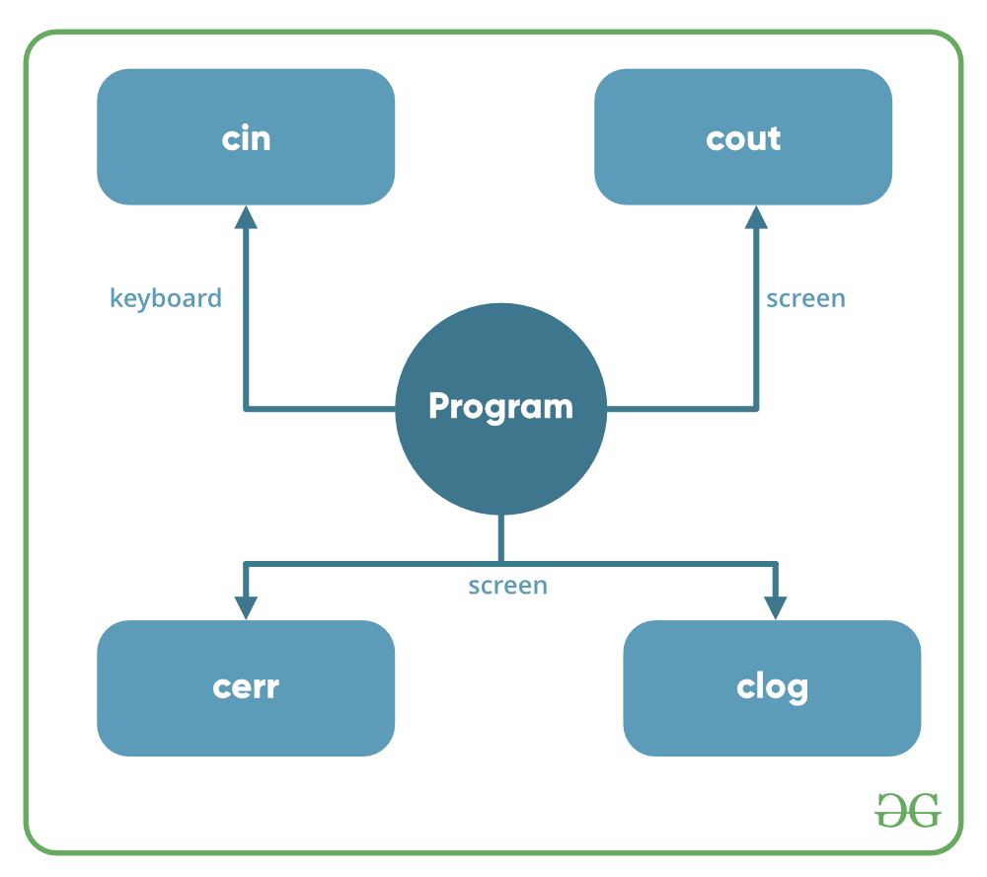
Header files available in C++ for Input/Output operations are:
- iostream: iostream stands for standard input-output stream. This header file contains definitions of objects like cin, cout, cerr, etc.
- iomanip: iomanip stands for input-output manipulators. The methods declared in these files are used for manipulating streams. This file contains definitions of setw, setprecision, etc.
- fstream: This header file mainly describes the file stream. This header file is used to handle the data being read from a file as input or data being written into the file as output.
- bits/stdc++: This header file includes every standard library. In programming contests, using this file is a good idea, when you want to reduce the time wasted in doing chores; especially when your rank is time sensitive. To know more about this header file refer this article.
In C++ after the header files, we often use ‘using namespace std;‘. The reason behind it is that all of the standard library definitions are inside the namespace std. As the library functions are not defined at global scope, so in order to use them we use namespace std. So, that we don’t need to write STD:: at every line (eg. STD::cout etc.). To know more refer this article.
The two instances cout in C++ and cin in C++ of iostream class are used very often for printing outputs and taking inputs respectively. These two are the most basic methods of taking input and printing output in C++. To use cin and cout in C++ one must include the header file iostream in the program.
Understanding input and output operations is essential for any C++ programmer. The C++ Course includes comprehensive lessons on basic I/O operations, ensuring you can manage user interaction in your programs.
This article mainly discusses the objects defined in the header file iostream like the cin and cout.
- Standard output stream (cout): Usually the standard output device is the display screen. The C++ cout statement is the instance of the ostream class. It is used to produce output on the standard output device which is usually the display screen. The data needed to be displayed on the screen is inserted in the standard output stream (cout) using the insertion operator(<<).
C++
Explain
#include <iostream>

using namespace std;

int main()
{
char sample[] = "GeeksforGeeks";

cout << sample << " - A computer science portal for geeks";

return 0;
}
Output:
GeeksforGeeks - A computer science portal for geeks
In the above program, the insertion operator(<<) inserts the value of the string variable sample followed by the string “A computer science portal for geeks” in the standard output stream cout which is then displayed on the screen.
- standard input stream (cin): Usually the input device in a computer is the keyboard. C++ cin statement is the instance of the class istream and is used to read input from the standard input device which is usually a keyboard.
The extraction operator(>>) is used along with the object cin for reading inputs. The extraction operator extracts the data from the object cin which is entered using the keyboard.
C++
Explain
#include <iostream>
using namespace std;

int main()
{
int age;

cout << "Enter your age:";
cin >> age;
cout << "\nYour age is: " << age;

return 0;
}
Input :
18
Output:
Enter your age:
Your age is: 18
The above program asks the user to input the age. The object cin is connected to the input device. The age entered by the user is extracted from cin using the extraction operator(>>) and the extracted data is then stored in the variable age present on the right side of the extraction operator.
- Un-buffered standard error stream (cerr): The C++ cerr is the standard error stream that is used to output the errors. This is also an instance of the iostream class. As cerr in C++ is un-buffered so it is used when one needs to display the error message immediately. It does not have any buffer to store the error message and display it later.
- The main difference between cerr and cout comes when you would like to redirect output using “cout” that gets redirected to file if you use “cerr” the error doesn’t get stored in file.(This is what un-buffered means ..It cant store the message)
C++
Explain
#include <iostream>

using namespace std;

int main()
{
cerr << "An error occurred";
return 0;
}
Output:
An error occurred

- buffered standard error stream (clog): This is also an instance of ostream class and used to display errors but unlike cerr the error is first inserted into a buffer and is stored in the buffer until it is not fully filled. or the buffer is not explicitly flushed (using flush()). The error message will be displayed on the screen too.
C++
Explain
#include <iostream>

using namespace std;

int main()
{
clog << "An error occurred";

return 0;
}
Output:
An error occurred
Related Articles:
- cout << endl vs cout << “\n” in C++
- Problem with scanf() when there is fgets()/gets()/scanf() after it
- How to use getline() in C++ when there are blank lines in input?
- Cin-Cout vs Scanf-Printf

cin in C++
In C++, cin is an object of istream class that is used to accept the input from the standard input stream i.e. stdin which is by default associated with keyboard. The extraction operator (>>) is used along with cin to extract the data from the object and insert it to the given variable.
Syntax
The syntax for using cin is:
cin >> var_name;
Here,
- >>: It is the extraction operator to extract data from cin.
- var_name: It is a variable that will store the input data provided by the user.
Note: cin is initialized when the program starts to make sure it is ready for input operations. It is also linked to cout to ensure that any buffered output is flushed before cin reads from the input stream.
Understanding how to use cin for input is fundamental in C++. To master input handling in your programs, consider exploring the C++ Course, which provides detailed explanations and practical examples.
Examples of cin
The following examples demonstrate how to use cin in C++ programs:
Example 1: Taking a Single Input from Keyboard
C++
Explain
// C++ program to demonstrate the use of cin
#include <iostream>
using namespace std;

int main() {

// Variable to store data given by cin
string s;

// Take input using cin
cin >> s;

// Print output
cout << s;
return 0;
}
Input
GeeksforGeeks
Output
GeeksforGeeks
Example 2: Taking Multiple Inputs Using the Extraction Operator(>>) with cin
C++
Explain
// C++ program to illustrate how to take multiple input
#include <iostream>
using namespace std;

int main() {
string name;
int age;

// Take multiple input using cin
cin >> name >> age;

// Print output
cout << "Name : " << name << endl;
cout << "Age : " << age << endl;

return 0;
}
Input
ABC 13
Output
Name : ABC
Age : 13
std::cin Member Functions in C++
The below table lists some commonly used member functions of std::cin in C++:
Member Function | Description
cin.get() | Reads a single character from the input stream, including whitespace.
cin.getline() | Reads a line of text, including whitespace, and stops when it reaches a newline character.
cin.ignore() | Ignores a specified number of characters or until a specified delimiter is encountered.
cin.peek() | Returns the next character from the input stream without extracting it.
cin.putback() | Puts a character back into the input stream.
cin.eof() | Returns true if the end of the input stream has been reached.
cin.fail() | Returns true if an input operation has failed (e.g., when input doesn’t match the expected type).
cin.clear() | Clears the error flags on the input stream, allowing further operations.
cin.sync() | Discards unread characters from the input buffer.
cin.gcount() | Returns the number of characters extracted by the last unformatted input operation.
cin.rdbuf() | Gets or sets the associated stream buffer object for std::cin.
cin.get()
It reads an input character and stores it in a variable. Below is the C++ program to implement cin.get():
C++
Explain
// C++ program to illustrate the use
// of cin.get()
#include <iostream>
using namespace std;

// Driver Code
int main()
{
char ch[30];
cin.get(ch, 25);

// Print ch
cout << ch;
}
Input
Welcome to GFG
Output
Welcome to GFG
cin.getline()
It reads a stream of characters of given length N into the string buffer. It stops when it has read (N – 1) characters or it finds the end of the file or newline character(\n). Below is the C++ program to implement cin.getline():
C++
Explain
// C++ program to illustrate the use of cin.getline
#include <iostream>
using namespace std;

int main() {
char name[5];

// Reads stream of 3 characters
cin.getline(name, 3);

// Print output
cout << name << endl;

return 0;
}
Input
Geeks
Output
Ge
cin.read()
It reads a stream of characters of given length N. Below is the C++ program to implement cin.read():
C++
Explain
// C++ program to illustrate the use of cin.read()
#include <iostream>
using namespace std;

int main() {
char gfg[20];

// Reads stream of characters
cin.read(gfg, 10);

// Print output
cout << gfg << endl;

return 0;
}
Input
Welcome to GFG
Output
Welcome to
cin.ignore()
It ignores or clears one or more characters from the input buffer. Below is the C++ program to implement cin.ignore():
C++
Explain
// C++ program to illustrate the use of cin.ignore()
#include <iostream>
#include <ios>
#include <limits>
using namespace std;

int main() {
int x;
char str[80];
cout << "Enter a number and string:\n";
cin >> x;

// clear buffer before taking
// new line
cin.ignore(numeric_limits<streamsize>::max(), '\n');

// Input a string
cin.getline(str, 80);
cout << "You have entered:\n";
cout << x << endl;
cout << str << endl;

return 0;
}
Input
Enter a number and string:
8
Welcome to GFG
Output
You have entered:
8
Welcome to GFG
Explanation: In the above program if cin.ignore() has not been used then after entering the number when the user presses the enter to input the string, the output will be only the number entered. The program will not take the string input. To avoid this problem cin.ignore() is used, this will ignore the newline character.

cout in C++
The cout object in C++ is an object of class iostream. It is defined in iostream header file. It is used to display the output to the standard output device i.e. monitor. It is associated with the standard C output stream stdout. The data needed to be displayed on the screen is inserted in the standard output stream (cout) using the insertion operator(<<).
Program 1:
Below is the C++ program to implement cout object:
- C++
// C++ program to illustrate the use
// of cout object
#include <iostream>
using namespace std;

// Driver Code
int main()
{
// Print standard output
// on the screen
cout << "Welcome to GFG";

return 0;
}
Output:
Welcome to GFG

Note: More than one variable can be printed using the insertion operator(<<) with cout.
Program 2:
Below is the C++ program to implement the above approach:
- C++
// C++ program to illustrate printing
// of more than one statement in a
// single cout statement
#include <iostream>
using namespace std;

// Driver Code
int main()
{
string name = "Akshay";
int age = 18;

// Print multiple variable on
// screen using cout
cout << "Name : " << name << endl
<< "Age : " << age << endl;

return 0;
}
Output:
Name : Akshay
Age : 18

The cout statement can also be used with some member functions:
- cout.write(char *str, int n): Print the first N character reading from str.
- cout.put(char &ch): Print the character stored in character ch.
- cout.precision(int n): Sets the decimal precision to N, when using float values.
Program 3:
Below is the implementation of the member functions of the cout.write() and cout.put():
- C++
// C++ program to illustrate the use
// of cout.write() and cout.put()
#include <iostream>
using namespace std;

// Driver Code
int main()
{
char gfg[] = "Welcome at GFG";
char ch = 'e';

// Print first 6 characters
cout.write(gfg, 6);

// Print the character ch
cout.put(ch);
return 0;
}
Output:
Welcome

Program 4:
Below is the C++ program to illustrate the use of cout.precision():
- C++
// C++ program toillustrate the use
// of cout.precision()
#include <iostream>
using namespace std;

// Driver Code
int main()
{
double pi = 3.14159783;

// Set precision to 5
cout.precision(5);

// Print pi
cout << pi << endl;

// Set precision to 7
cout.precision(7);

// Print pi
cout << pi << endl;

return 0;
}
Output:
3.1416
3.141598

cerr – Standard Error Stream Object in C++
Standard output stream(cout): cout is the instance of the ostream class. cout is used to produce output on the standard output device which is usually the display screen. The data needed to be displayed on the screen is inserted in the standard output stream(cout) using the insertion operator(<<).
Standard error stream (cerr): cerr is the standard error stream which is used to output the errors. It is an instance of the ostream class. As cerr stream is un-buffered so it is used when we need to display the error message immediately and does not store the error message to display later. The object of class ostream that represents the standard error stream oriented to narrow characters(of type char). It corresponds to the C stream stderr.
The “c” in cerr refers to “character” and ‘err’ means “error”, Hence cerr means “character error”. It is always a good practice to use cerr to display errors.
Below is the program to illustrate cerr:
// C++ program to illustrate std::cerr

#include <iostream>
using namespace std;

// Driver Code
int main()
{

// This will print "Welcome to GfG"
// in the error window
cerr << "Welcome to GfG! :: cerr";

// This will print "Welcome to GfG"
// in the output window
cout << "Welcome to GfG! :: cout";
return 0;
}
In the above program the Output of Line 11 will display an error window as:
RunTime Error in CPP code:
Welcome to GfG! :: cerr

Manipulators in C++ with Examples
Manipulators are helping functions that can modify the input/output stream. It does not mean that we change the value of a variable, it only modifies the I/O stream using insertion (<<) and extraction (>>) operators.
- Manipulators are special functions that can be included in the I/O statement to alter the format parameters of a stream.
- Manipulators are operators that are used to format the data display.
- To access manipulators, the file iomanip.h should be included in the program.
For example, if we want to print the hexadecimal value of 100 then we can print it as:
cout<<setbase(16)<<100
Types of Manipulators There are various types of manipulators:
- Manipulators without arguments: The most important manipulators defined by the IOStream library are provided below.
  - endl: It is defined in ostream. It is used to enter a new line and after entering a new line it flushes (i.e. it forces all the output written on the screen or in the file) the output stream.
  - ws: It is defined in istream and is used to ignore the whitespaces in the string sequence.
  - ends: It is also defined in ostream and it inserts a null character into the output stream. It typically works with std::ostrstream, when the associated output buffer needs to be null-terminated to be processed as a C string.
  - flush: It is also defined in ostream and it flushes the output stream, i.e. it forces all the output written on the screen or in the file. Without flush, the output would be the same, but may not appear in real-time.
Examples:
- CPP
#include <iostream>
#include <istream>
#include <sstream>
#include <string>

using namespace std;

int main()
{
istringstream str(" Programmer");
string line;
// Ignore all the whitespace in string
// str before the first word.
getline(str >> std::ws, line);

// you can also write str>>ws
// After printing the output it will automatically
// write a new line in the output stream.
cout << line << endl;

// without flush, the output will be the same.
cout << "only a test" << flush;

// Use of ends Manipulator
cout << "\na";

// NULL character will be added in the Output
cout << "b" << ends;
cout << "c" << endl;

return 0;
}
Output:
Programmer
only a test
abc
- Manipulators with Arguments: Some of the manipulators are used with the argument like setw (20), setfill (‘*’), and many more. These all are defined in the header file. If we want to use these manipulators then we must include this header file in our program. For Example, you can use following manipulators to set minimum width and fill the empty space with any character you want: std::cout << std::setw (6) << std::setfill (’*’);
  - Some important manipulators in <iomanip> are:
    - setw (val): It is used to set the field width in output operations.
    - setfill (c): It is used to fill the character ‘c’ on output stream.
    - setprecision (val): It sets val as the new value for the precision of floating-point values.
    - setbase(val): It is used to set the numeric base value for numeric values.
    - setiosflags(flag): It is used to set the format flags specified by parameter mask.
    - resetiosflags(m): It is used to reset the format flags specified by parameter mask.
  - Some important manipulators in <ios> are:
    - showpos: It forces to show a positive sign on positive numbers.
    - noshowpos: It forces not to write a positive sign on positive numbers.
    - showbase: It indicates the numeric base of numeric values.
    - uppercase: It forces uppercase letters for numeric values.
    - nouppercase: It forces lowercase letters for numeric values.
    - fixed: It uses decimal notation for floating-point values.
    - scientific: It uses scientific floating-point notation.
    - hex: Read and write hexadecimal values for integers and it works same as the setbase(16).
    - dec: Read and write decimal values for integers i.e. setbase(10).
    - oct: Read and write octal values for integers i.e. setbase(10).
    - left: It adjusts output to the left.
    - right: It adjusts output to the right.
There are two types of manipulators used generally:
1] Parameterized and
2] Non-parameterized
1] Parameterized Manipulators:-
Manipulator -> Meaning
setw (int n) -> To set field width to n
setprecision (int p) -> The precision is fixed to p
setfill (Char f) -> To set the character to be filled
setiosflags (long l) -> Format flag is set to l
resetiosflags (long l) -> Removes the flags indicated by l
Setbase(int b) -> To set the base of the number to b
setw () is a function in Manipulators in C++:
The setw() function is an output manipulator that inserts whitespace between two variables. You must enter an integer value equal to the needed space.
Syntax:
setw ( int n)
As an example,
int a=15; int b=20;
cout << setw(10) << a << setw(10) << b << endl;
setfill() is a function in Manipulators in C++:
It replaces setw(whitespaces )’s with a different character. It’s similar to setw() in that it manipulates output, but the only parameter required is a single character.
Syntax:
setfill(char ch)
Example:
int a,b;
a=15; b=20;
cout<< setfill(‘*’) << endl;
cout << setw(5) << a << setw(5) << a << endl;
Example:
float A = 1.34255;
cout <<fixed<< setprecision(3) << A << endl;
setbase() is a function in Manipulators in C++:
The setbase() manipulator is used to change the base of a number to a different value. The following base values are supported by the C++ language:
• hex (Hexadecimal = 16)
• oct (Octal = 8)
• dec (Decimal = 10)
The manipulators hex, oct, and dec can change the basis of input and output numbers.
- C++
// Example:

#include <iostream>
#include <iomanip>

using namespace std;
main()
{

int number = 100;

cout << "Hex Value =" << " " << hex << number << endl;

cout << "Octal Value=" << " " << oct << number << endl;

cout << "Setbase Value=" << " " << setbase(8) << number << endl;

cout << "Setbase Value=" << " " << setbase(16) << number << endl;

return 0;

}
Output
Hex Value = 64
Octal Value= 144
Setbase Value= 144
Setbase Value= 64
2 ] Non-parameterized
Examples are endl, fixed, showpoint and flush.
• endl – Gives a new line
• ends – Adds null character to close an output string
• flush – Flushes the buffer stream
• ws – Omits the leading white spaces present before the first field
• hex, oct, dec – Displays the number in hexadecimal or octal or in decimal format
- C++
// Example: ws – Omits the leading white spaces present before the first field

#include<iostream>
using namespace std;

int main()

{
char name[125];
cout << "Enter your name" << endl;

cin >> ws;

cin.getline(name,125);

cout << name << endl;

return 0;
}
Output
Enter your name
ram
ram
References:
- http://www.cplusplus.com/reference/iomanip/
- http://www.cplusplus.com/reference/ios/basic_ios/
- http://www.cplusplus.com/reference/ios/

Array

1d array
- an array is a derived data type that is used to store multiple values of similar data types in a contiguous memory location.
- Create array: data_type array_name [size]
- Traverse Array:using for loop we can access in the array one by one form 0 index to (size -1) index.
ex:
include <iostream>
using namespace std;

int main() {
int arr[5] = {2, 4, 8, 12, 16};

// Traversing and printing arr
for (int i = 0; i < 5; i++)
cout << arr[i] << " ";

return 0;
}

- Size of an array:
ex: char arr[] = {'a', 'b', 'c', 'd', 'f'};
// Size of one element of an array
cout << "Size of arr[0]: " << sizeof(arr[0]) << endl;
// Size of 'arr'
cout << "Size of arr: " << sizeof(arr) << endl;
// Length of an array int n = sizeof(arr) / sizeof(arr[0]);
- Passing array to Function:arrays are passed to function using pointers.there are three common method:1.unsized array notation-where array is passed without declaring the size.
2.sized array notation -where arry is passed with the size declaration.
3. Pointer notation- where the array is explicitly passed as a pointer, often
along with its size.
Ex:
// Functions that take array as argument
void sized_array_notation(int arr[5]) {}

void unsized_array_notation(int arr[]) {}

void pointer_notation(int* arr) {}

int main() {
int arr[] = {2, 4, 8, 12, 16};
int n = sizeof(arr) / sizeof(arr[0]);

// Passing array
sized_array_notation(arr);
unsized_array_notation(arr);
pointer_notation(arr);

2d array
- A Two-Dimensional array or 2D array in C is an array that has exactly two dimensions.
Ex:
#include <stdio.h>

int main() {

// 2D array declaration
int arr[4][4];

// Initialize 2d array
for(int i = 0; i<4; i++){
int val = 1;
for(int j = 0; j < 4; j++){
arr[i][j] = val++;
}
}

3d array
Ex: // 3D array declaration (3 layers, 3 rows, 3 columns)
int arr[3][3][3];

// Filling the 3D array
for(int i = 0; i < 3; i++) {
for(int j = 0; j < 3; j++) {
int val = 1;
for(int k = 0; k < 3; k++) {
arr[i][j][k] = val++;
}
}
}

function

Basic
A function in C is a set of statements that when called perform some specific tasks. It is the basic building block of a C program that provides modularity and code reusability. The programming statements of a function are enclosed within { } braces, having certain meanings and performing certain operations. They are also called subroutines or procedures in other languages.

Syntax of Functions in C
The syntax of function can be divided into 3 aspects:
- Function Declaration
- Function Definition
- Function Calls

Function Declarations
In a function declaration, we must provide the function name, its return type, and the number and type of its parameters. A function declaration tells the compiler that there is a function with the given name defined somewhere else in the program.
Syntax
return_type name_of_the_function (parameter_1, parameter_2);
The parameter name is not mandatory while declaring functions. We can also declare the function without using the name of the data variables.
Example
int sum(int a, int b); // Function declaration with parameter names
int sum(int , int); // Function declaration without parameter names
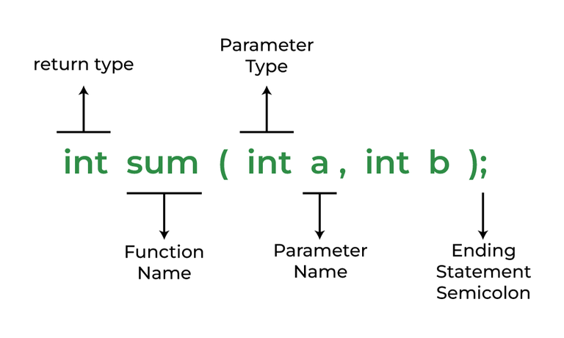
Function Declaration
Note: A function in C must always be declared globally before calling it.

Function Definition
The function definition consists of actual statements which are executed when the function is called (i.e. when the program control comes to the function).
A C function is generally defined and declared in a single step because the function definition always starts with the function declaration so we do not need to declare it explicitly. The below example serves as both a function definition and a declaration.
return_type function_name (para1_type para1_name, para2_type para2_name)
{
// body of the function
}
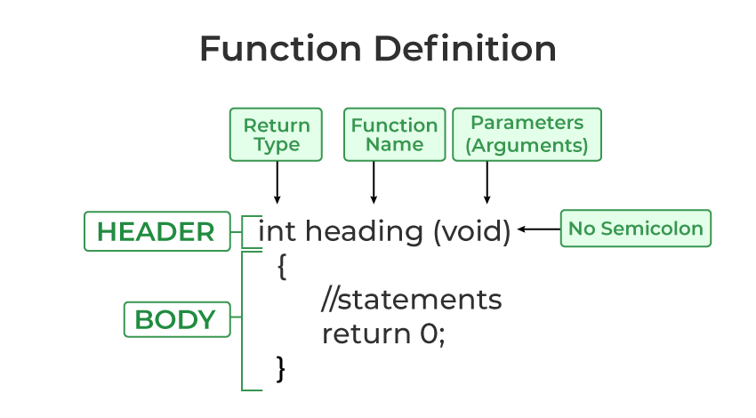
Function Definition in C

Function Call
A function call is a statement that instructs the compiler to execute the function. We use the function name and parameters in the function call.
In the below example, the first sum function is called and 10,30 are passed to the sum function. After the function call sum of a and b is returned and control is also returned back to the main function of the program.
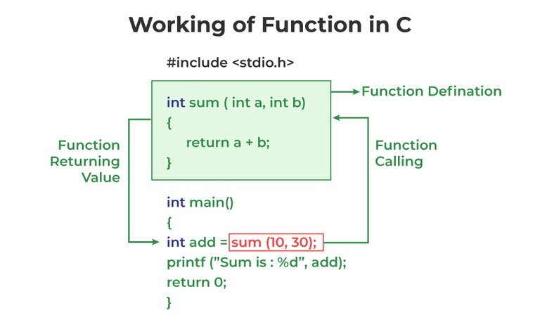

Working of function in C
Note: Function call is neccessary to bring the program control to the function definition. If not called, the function statements will not be executed.
Example of C Function
// C program to show function
// call and definition
#include <stdio.h>

// Function that takes two parameters
// a and b as inputs and returns
// their sum
int sum(int a, int b)
{
return a + b;
}

// Driver code
int main()
{
// Calling sum function and
// storing its value in add variable
int add = sum(10, 30);

printf("Sum is: %d", add);
return 0;
}
Output
Sum is: 40
As we noticed, we have not used explicit function declaration. We simply defined and called the function.

Function Return Type
Function return type tells what type of value is returned after all function is executed. When we don’t want to return a value, we can use the void data type.
Example:
int func(parameter_1,parameter_2);
The above function will return an integer value after running statements inside the function.
Note: Only one value can be returned from a C function. To return multiple values, we have to use pointers or structures.
Function Arguments
Function Arguments (also known as Function Parameters) are the data that is passed to a function.
Example:
int function_name(int var1, int var2);

Conditions of Return Types and Arguments
In C programming language, functions can be called either with or without arguments and might return values. They may or might not return values to the calling functions.
- Function with no arguments and no return value
- Function with no arguments and with return value
- Function with argument and with no return value
- Function with arguments and with return value
To know more about function Arguments and Return values refer to the article – Function Arguments & Return Values in C.

How Does C Function Work?
Working of the C function can be broken into the following steps as mentioned below:
- Declaring a function: Declaring a function is a step where we declare a function. Here we specify the return types and parameters of the function.
- Defining a function: This is where the function’s body is provided. Here, we specify what the function does, including the operations to be performed when the function is called.
- Calling the function: Calling the function is a step where we call the function by passing the arguments in the function.
- Executing the function: Executing the function is a step where we can run all the statements inside the function to get the final result.
- Returning a value: Returning a value is the step where the calculated value after the execution of the function is returned. Exiting the function is the final step where all the allocated memory to the variables, functions, etc is destroyed before giving full control back to the caller.

Types of Functions
There are two types of functions in C:
- Library Functions
- User Defined Functions
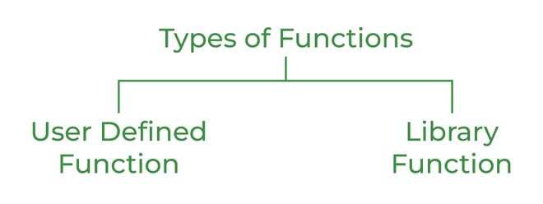
Types of Functions in C
1. Library Function
A library function is also referred to as a “built-in function”. A compiler package already exists that contains these functions, each of which has a specific meaning and is included in the package. Built-in functions have the advantage of being directly usable without being defined, whereas user-defined functions must be declared and defined before being used.
For Example:
pow(), sqrt(), strcmp(), strcpy() etc.
Advantages of C library functions
- C Library functions are easy to use and optimized for better performance.
- C library functions save a lot of time i.e, function development time.
- C library functions are convenient as they always work.
Example:
// C program to implement
// the above approach
#include <math.h>
#include <stdio.h>

// Driver code
int main()
{
double Number;
Number = 49;

// Computing the square root with
// the help of predefined C
// library function
double squareRoot = sqrt(Number);

printf("The Square root of %.2lf = %.2lf",
Number, squareRoot);
return 0;
}
Output
The Square root of 49.00 = 7.00
2. User Defined Function
Functions that the programmer creates are known as User-Defined functions or “tailor-made functions”. User-defined functions can be improved and modified according to the need of the programmer. Whenever we write a function that is case-specific and is not defined in any header file, we need to declare and define our own functions according to the syntax.
Advantages of User-Defined Functions
- Changeable functions can be modified as per need.
- The Code of these functions is reusable in other programs.
- These functions are easy to understand, debug and maintain.
Example:
// C program to show
// user-defined functions
#include <stdio.h>

int sum(int a, int b)
{
return a + b;
}

// Driver code
int main()
{
int a = 30, b = 40;

// function call
int res = sum(a, b);

printf("Sum is: %d", res);
return 0;
}
Output
Sum is: 70

Passing Parameters to Functions
The data passed when the function is being invoked is known as the Actual parameters. In the below program, 10 and 30 are known as actual parameters. Formal Parameters are the variable and the data type as mentioned in the function declaration. In the below program, a and b are known as formal parameters.
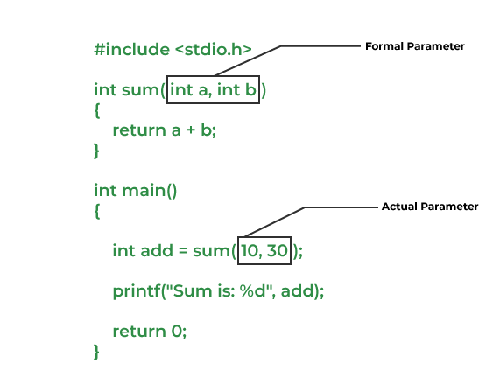
Passing Parameters to Functions
We can pass arguments to the C function in two ways:
- Pass by Value
- Pass by Reference
1. Pass by Value
Parameter passing in this method copies values from actual parameters into formal function parameters. As a result, any changes made inside the functions do not reflect in the caller’s parameters.
Example:
// C program to show use
// of call by value
#include <stdio.h>

void swap(int var1, int var2)
{
int temp = var1;
var1 = var2;
var2 = temp;
}

// Driver code
int main()
{
int var1 = 3, var2 = 2;
printf("Before swap Value of var1 and var2 is: %d, %d\n",
var1, var2);
swap(var1, var2);
printf("After swap Value of var1 and var2 is: %d, %d",
var1, var2);
return 0;
}
Output
Before swap Value of var1 and var2 is: 3, 2
After swap Value of var1 and var2 is: 3, 2
2. Pass by Reference
The caller’s actual parameters and the function’s actual parameters refer to the same locations, so any changes made inside the function are reflected in the caller’s actual parameters.
Example:
// C program to show use of
// call by Reference
#include <stdio.h>

void swap(int *var1, int *var2)
{
int temp = *var1;
*var1 = *var2;
*var2 = temp;
}

// Driver code
int main()
{
int var1 = 3, var2 = 2;
printf("Before swap Value of var1 and var2 is: %d, %d\n",
var1, var2);
swap(&var1, &var2);
printf("After swap Value of var1 and var2 is: %d, %d",
var1, var2);
return 0;
}
Output
Before swap Value of var1 and var2 is: 3, 2
After swap Value of var1 and var2 is: 2, 3
Advantages of Functions in C
Functions in C is a highly useful feature of C with many advantages as mentioned below:
- The function can reduce the repetition of the same statements in the program.
- The function makes code readable by providing modularity to our program.
- There is no fixed number of calling functions it can be called as many times as you want.
- The function reduces the size of the program.
- Once the function is declared you can just use it without thinking about the internal working of the function.
Disadvantages of Functions in C
The following are the major disadvantages of functions in C:
- Cannot return multiple values.
- Memory and time overhead due to stack frame allocation and transfer of program control.
Conclusion
In this article, we discussed the following points about the function as mentioned below:
- The function is the block of code that can be reused as many times as we want inside a program.
- To use a function we need to call a function.
- Function declaration includes function_name, return type, and parameters.
- Function definition includes the body of the function.
- The function is of two types user-defined function and library function.
- In function, we can according to two types call by value and call by reference according to the values passed.
Function parameters are the values declared in a function declaration. Whereas, function arguments are the values that are passed in the function during the function call.
Example:

Parameter Passing Techniques in C

In C, passing values to a function means providing data to the function when it is called so that the function can use or manipulate that data. Here:
- Formal Parameters: Variables used in parameter list in a function declaration/definition as placeholders. Also called only parameters.
- Actual Parameters: The actual expression or values passed in during a function call. Also called arguments.
There are two main techniques for passing parameters to functions in C:
Table of Content
- Pass By Value
- Pass by Pointers
Pass By Value
In this method, a copy of the argument is passed to the function. The function works on this copy, so any changes made to the parameter inside the function do not affect the original argument. It is also known as call by value.
Example:
{...}
// Function that takes parameters by value
void func(int val) {

// Changing the value
val = 123;
}

int main() {
int x = 1;

// Passing x by value to func()
func(x);
printf("%d", x);

{...}
Output
1
As we can see, the value of x remains unchanged because the function func() takes its parameter val by value, meaning a copy of x is passed to the function. When val is modified inside func(), it only alters the copy, not the original variable x in main(). As a result, printf(“%d”, x) outputs 1, the original value of x.
This method is simple to understand and implement but it is inefficient for large arrays or structures because making copies of them is costly.
Note: Languages like C, C++, and Java support this type of parameter passing. Java in fact is strictly call by value.
Pass by Pointers
This method uses a pointer as a parameter to receive the address of the data that is passed to the function in the function call as argument. This allows the function to access and modify the content at that particular memory location, hence, modifications done in the function are reflected in the original value. It is also known as call by pointers.
Example:
{...}
// Function that takes parameters by pointer
void func(int* val) {

// Changing the value
*val = 123;
}

int main() {
int x = 1;

// Passing address of x
func(&x);
printf("%d", x);

{...}
Output
123
As we can see, the value of x changes because func() takes a pointer int* val, which receives the memory address of x. Inside func(), *val = 123 dereferences the pointer and modifies the value at that address, directly altering x in main(). Thus, printf(“%d”, x) outputs 123.
This method is a bit complex and error prone as it involves pointers, but it is efficient when passing large arrays or structure. It also allows functions to modify the variable declared somewhere else.
Note: This method is sometimes called as Pass by (or Call by) Reference. But it is not to be confused with Call by Reference from other programming languages like C++.
Call by Value vs Call by Reference
The following table lists primary differences between the call-by-value and call-by-reference methods of parameter passing in C:
Difference | Call-by-Value | Call-by-Reference
Definition | Passes a copy of the argument value to the function. | Passes the address (reference) of the argument.
Effect on Original Argument | Original argument remains unchanged after the function call. | Original argument can be modified within the function.
Memory Usage | Requires more memory as a copy of the argument is created. | More memory-efficient as only the address is passed.

